

[**Liverpool John Moores University**](http://ljmu.ac.uk/)

**Image Geolocation based on Multi-faceted Features.**

**Mohamed Arezki Ibersienne**

Supervisor:

Dr Carl Chalmers

A thesis submitted in partial fulfilment for the

Degree of Masters in Artificial Intelligence (Machine Learning)

in the

Faculty of

Engineering and Technology

September 2023

Declaration

I solemnly declare that the research work embodied in this thesis has been conducted under the aegis of the Faculty of Engineering and Technology at Liverpool John Moores University. Unless explicitly mentioned otherwise, all the work presented herein is my own original undertaking.

During the tenure of my registration as a candidate for the Masters in Artificial Intelligence (Machine Learning), for which this submission is now made, I have not been enrolled as a candidate for any other academic award. Moreover, the research and arguments presented in this thesis have not been submitted, either in whole or in part, for any other degree or professional qualification.

Faculty of Engineering and Technology

Liverpool John Moores University James Parsons Building

Byrom Street Liverpool

L3 3AF

UK

Abstract

This thesis presents a novel approach to geo-prediction using machine learning techniques, specifically focusing on outdoor urban scenes. Unlike traditional object detection models, the primary objective of this research is to predict geographical features based on multiple attributes such as architecture, weather conditions, and signs. The methodology employs a Faster R-CNN model with a ResNet-50 backbone and Feature Pyramid Network (FPN) for real-time object detection, fine-tuned for 33 unique object categories. The model was trained on a high-performance NVIDIA A100 GPU, facilitated by Google Colab Pro.The evaluation metrics were tailored to assess the model's proficiency in geo-prediction rather than object detection. The model underwent 40 epochs of training, with early stopping mechanisms to prevent overfitting. The training and validation accuracies peaked at approximately 84.99% and 86.60%, respectively, before showing signs of overfitting. Loss values indicated effective learning.

**Keywords**: Geo-prediction, Machine Learning, Faster R-CNN, ResNet-50, Feature Pyramid Network, Object Detection, Urban Scenes, Overfitting, Early Stopping, NVIDIA A100 GPU, Validation Accuracy, Training Accuracy.

Acknowledgements

First and foremost, I would like to extend my deepest gratitude to Dr. Carl Chalmers and Prof. Paul Fergus for their invaluable guidance, mentorship, and support throughout the course of this research. Your expertise and insights have been instrumental in shaping this work, and I am truly grateful for the opportunity to learn from such distinguished professionals.

To my parents, words cannot express how thankful I am for your unwavering love and support, especially during this challenging year. Your sacrifices and encouragement have been my driving force, and this achievement is as much yours as it is mine.

I would also like to thank everyone who has supported me throughout this journey. The process of developing this model was arduous, but your support made it bearable and even enjoyable at times. Whether it was a word of encouragement, a listening ear, or a helping hand, each one of you has contributed to this achievement in your own special way.

In a year that has tested us all, I am reminded of the strength and resilience that can be found in unity and mutual support. Thank you all for being a part of this incredible journey.

# Contents

Declaration 2

Abstract 3

Acknowledgements 4

Contents 5

Chapter 1 1

Introduction 1

1.1 Urban Landscapes as Data Points in Image-Based Geolocation 1

1.2 Limitations of Traditional Geolocation Techniques 3

1.3 Cognitive Biases and the Role of Deep Learning in Image-Based Geolocation 5

1.4 Building on Deep Learning 6

Chapter 2 12

Background and Literature Review 12

2.1 Evolution and Importance of Image-Based Geolocation 12

2.2 Traditional Geolocation Techniques and Their Limitations 13

2.3 Role of Deep Learning in Geolocation 15

2.4 Data Standardization and Ontology 17

2.5 Challenges and Solutions in Large-Scale Visual Recognition 18

2.6 Attention Mechanisms and Hierarchical Classification 20

Chapter 3 24

Analysis and Design 24

3.1 Data Preparation 24

3.2 Exploratory Data Analysis 33

3.3 Data Augmentation 41

3.4 Model Architecture 41

3.5 Model Training 48

3.6 Model Inference 50

3.7 Evaluation metrics 52

Chapter 4 55

Evaluation 55

4.1 Performance Metrics 55

4.2 Inferencing 59

4.3 Summary 61

Chapter 5 63

Discussion 63

5.1 Revisiting the Research Objectives and Hypotheses 63

5.2 Complexity and Nuances of the Model Architecture 63

5.3 The Good, the Bad, and the Complex 64

5.4 Dataset Diversity and Limitations 64

5.5 The Paradox of Complexity and Dataset Size 64

5.6 Potential for Scalability 65

5.7 An Indication for Future Research 66

5.8 Addressing Overfitting and Generalization 66

5.9 Relevance to Real-world Applications 66

Chapter 6 68

Conclusion and Future work 68

6.1 Conclusion 68

6.2 Future Work 70

6.3 Addressing Hypotheses and Aims: A Reflective Analysis 73

References 75

# 

## Introduction

### Urban Landscapes as Data Points in Image-Based Geolocation

In the field of computer vision, image-based geolocation has emerged as a critical research area with extensive practical applications, including but not limited to urban planning, national security, and emergency response. The capability to accurately determine the geographical coordinates of an image has significant utility across these sectors. Moreover, the development of robust geo-localization models has a cascading effect on the broader field of computer vision. For instance, consider a computer vision model designed to identify specific animal species. If this model is integrated with a geo-localization algorithm, it can significantly improve its accuracy. Knowing that a particular species of lion is native to certain geographic regions can help the model make more accurate identifications. This is particularly useful for conservation efforts, where precise data is crucial. Similarly, in the context of national security, combining facial recognition algorithms with geo-localization can provide a more comprehensive profile of potential security threats. The geo-tags can help in tracking the movements of individuals, thereby aiding in predictive policing. Furthermore, in disaster management and emergency response scenarios, geo-localized images can provide real-time data that is invaluable for rescue operations. For example, during floods, a geo-localized image can give rescue teams information not just about the extent of the flooding, but also its exact location, thereby facilitating more effective interventions. With the exponential growth in the availability of geotagged images and advancements in machine learning algorithms, there is an increasing need for robust and accurate methods to automatically determine the geographical location of an image. This challenge involves multidisciplinary approaches that draw on spatial informatics, pattern recognition, and machine learning, aiming to bridge the gap between visual data and geographical coordinates, a feat that holds transformative potential for understanding and navigating urban landscapes. For instance, Tokyo's distinct neon signage and landmarks like the Tokyo Tower are not merely aesthetic elements but unique identifiers that contribute to the city's digital fingerprint. These visual cues are crucial for algorithms that aim to bridge the domain gap between ground and aerial images for more accurate geo-localization [1]. Similarly, Liverpool's historical docks and cultural landmarks, such as those associated with The Beatles, provide a rich dataset for multi-temporal geo-localization algorithms. These algorithms leverage time-series data to improve the accuracy of location prediction, especially in cities with significant historical landmarks [2]. In the other hand Algiers offers a unique blend of French colonial architecture and traditional North African elements, like the lanes in its ancient Casbah. This architectural diversity is particularly beneficial for cross-view image geo-localization algorithms that require a robust backbone to handle a variety of architectural elements across different cultures [3]. The complexity and diversity of urban landscapes make them ideal testing grounds for advancing image-based geolocation technologies. As these algorithms become more sophisticated, they hold the potential to revolutionize various fields. In the contemporary digital ecosystem, images are not merely visual artifacts; they serve as complex repositories of information, narratives, and in certain cases, vital evidence. This has led to the burgeoning importance of geo-localization technologies capable of decoding the geographical narratives embedded within images. Cutting-edge advancements in this field have not only achieved unprecedented accuracy down to the sub-pixel level but have also shown marked improvements in cross-area evaluations, making them invaluable tools for various applications [2], the seamless integration of digital and physical realms has elevated the significance of images as critical assets for law enforcement agencies. Photographs shared on social media platforms, particularly those featuring recognizable landmarks or cityscapes, can offer crucial leads in a range of investigations. This is especially true in the context of data protection, privacy, and security where artificial intelligence and conventional methods are increasingly being employed for law enforcement purposes [4]. The role of image-based geo-localization in enhancing global security measures cannot be overstated. It serves as a pivotal tool in the arsenal of law enforcement agencies, aiding in everything from routine investigations to national security concerns. This is particularly true in the context of unmanned aerial vehicles (UAVs), where deep learning-based cross-view image matching has shown promising results in geo-localization tasks [5].

### Limitations of Traditional Geolocation Techniques

Traditional geolocation methods often rely heavily on metadata, such as GPS coordinates, to determine the location of an image. While this approach is straightforward, it has significant limitations. Metadata can be easily manipulated or stripped from an image, rendering it an unreliable tool for accurate geolocation. This vulnerability exposes a critical gap in security applications, where manipulated metadata can mislead investigations. Another limitation is the geolocation error estimation, especially in complex data like satellite imagery. Techniques like the ℓp-ICP Coastline Inflection Method have been developed to estimate geolocation errors in FY-3 MWRI Data. However, these methods are not universally applicable and can significantly impact the reliability of geolocation in critical applications like weather forecasting [6].

Similarly, in the context of mobile incident management systems, traditional geolocation techniques may not provide the real-time accuracy required for emergency response. Systems like React Native-based mobile incident management have shown that relying solely on traditional methods can result in significant delays and inaccuracies, affecting the effectiveness of emergency services [7]. Traditional methods are often inadequate for complex geolocation scenarios, such as railway condition monitoring. Hybrid approaches that combine multi-view stereopsis and real-time kinematic geolocation pipelines have been developed to address these complexities. However, these are still in the experimental stage and are not yet widely adopted [8].

Those dated techniques often struggle in diverse environmental conditions. For instance, methods that work well in urban settings may not be applicable in rural or wilderness areas. This lack of robustness limits the utility of traditional methods in applications like wildlife conservation or disaster management, but also in cities with significant historical landmarks, traditional geolocation methods often fail to leverage time-series data effectively. This is a significant limitation in multi-temporal geolocation algorithms, which require robust methods to improve the accuracy of location prediction over time. Given these limitations, there is a growing need for more intrinsic, content-based approaches to image geolocation.

Deep learning-based pipelines and street view images are emerging as promising alternatives. These methods aim to improve both the accuracy and reliability of image-based geolocation, offering a more comprehensive solution for various applications. The limitations of traditional geolocation techniques are manifold, ranging from reliability issues with metadata to inadequacies in handling complex and diverse scenarios. These challenges have catalyzed the development of more advanced, content-based approaches that leverage machine learning and other computational methods. As the field of image-based geolocation continues to evolve, addressing these limitations will be crucial for developing more reliable systems.

### Cognitive Biases and the Role of Deep Learning in Image-Based Geolocation

The human brain, often considered an evolutionary marvel, possesses an innate ability to process visual stimuli with remarkable efficiency. This cognitive skill extends to the task of geolocating images based solely on visual cues. While the brain's guesses may sometimes be inaccurate, they often come close to the actual geographical location, highlighting the brain's inherent capability for spatial recognition [9].

However, this cognitive process is not without its limitations. Personal biases, experiences, and cultural exposure can significantly influence the interpretation of visual information. For example, someone who has lived their entire life in a mountainous region may find it challenging to accurately geolocate an image of a desert landscape. These cognitive biases present a unique challenge in the field of image-based geolocation, where the objective is to develop algorithms that can universally and accurately determine the geographical origins of images [10]. To address these challenges, our research takes inspiration from the neural networks that constitute the human brain. Deep learning algorithms, particularly convolutional neural networks (CNNs), have shown promise in mimicking the human brain's ability to process visual information. These algorithms can be trained to recognize a wide array of features, from obvious landmarks to more subtle cues like architectural styles or vegetation types. By leveraging advanced techniques like transfer learning and data augmentation, our proposed deep learning system aims to go beyond merely mimicking human cognition. The goal is to create a system that is not only accurate but also robust and adaptable to various types of visual information [11].

A critical aspect of this research is the use of diverse training data. By training the model on a wide range of images, from Tokyo's bustling Shibuya crossing to Liverpool's historic Albert Dock and Algiers' Mediterranean coastline, we aim to create a system that is universally applicable. This diversity allows the model to recognize both well-known landmarks and subtler, often overlooked details that are crucial for accurate geo-localization. The use of diverse training data also mitigates the impact of cognitive biases, making the model more robust and reliable.

The limitations of traditional geolocation techniques, such as the reliance on manipulable metadata and the lack of robustness in diverse environments, make the role of deep learning even more critical. Deep learning algorithms offer a more intrinsic, content-based approach to image geolocation, providing a comprehensive solution that addresses the limitations of traditional methods.

### Building on Deep Learning

One might argue that human cognition is remarkably adept at identifying geographical locations based on visual cues. However, this cognitive skill is far from infallible. The world is replete with regions that, despite being geographically distant, share strikingly similar visual characteristics. Whether it's the architectural styles, natural landscapes, or even weather conditions, these similarities can easily mislead human judgment. For instance, a cobblestone street flanked by colonial-style buildings could as easily be in a historic district of Italy as in a similar setting in Liverpool.



Figure 1 Side-by-side image of a street in Tokyo and a street in Foshan that look similar.

This inherent challenge underscores the need for a more reliable, machine-driven approach to image-based geolocation, one that can disambiguate between visually similar but geographically distinct locales. Considering the limitations of traditional geolocation methods and the promising capabilities of deep learning, this research introduces a novel model architecture designed to push the boundaries of image-based geo-localization. The model aims to serve as a comprehensive solution, specifically tailored to operate in diverse urban environments like Liverpool, Algiers, and Tokyo.

The foundational layer of the model is the Faster R-CNN architecture, a well-established object detection model that has been widely adopted in various computer vision tasks [12].

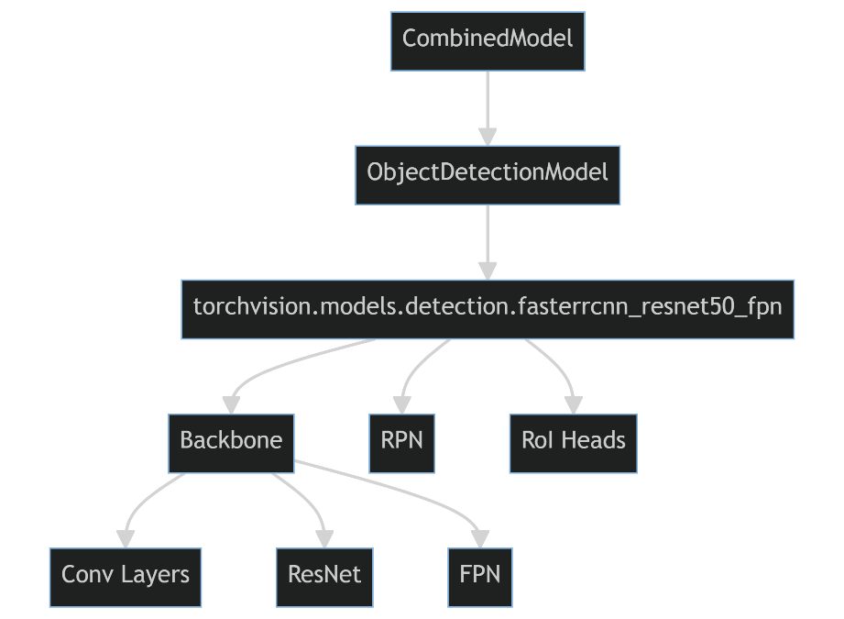

Figure 2 Faster R-CNN Architecture

This choice of backbone serves as the primary feature extractor, capturing essential visual cues from the input images. The model transcends traditional geo-localization techniques by amalgamating multiple features such as architecture, weather, signs, text language, and vehicles Figure 3. This multi-feature approach is inspired by recent advancements in deep spatio-temporal predictive modelling[13] and self-adaptive networks [14]. The integration of these diverse features aims to enhance the model's robustness and adaptability across different environments.



Figure 3 Picture of Tokyo Label across multiple features

The features extracted by Faster R-CNN are then channeled through a hierarchical classification layer. To address the challenge of handling images with a diverse set of features, an attention mechanism is incorporated. This mechanism weighs the importance of different features dynamically, a technique that has shown promise in tasks like signal strength prediction using geographical images [15]. The final layer is the Geo-Prediction Layer, which takes the aggregated features to make the final geo-localization prediction. This layer employs advanced algorithms for cross-view image matching, drawing inspiration from recent works in UAV localization1 and orientation estimation [16].

By integrating these advanced techniques and layers, the model aims to set a new standard in the field of image-based geo-localization. Designed to be both robust and adaptable, capable of handling the complexities and nuances of different urban landscapes.

The primary objective of this research is to develop a robust, deep learning-based model for image-based geolocation that addresses the limitations of traditional methods and human cognition. Specifically, the aim is to:

* Develop a model that can accurately geolocate images based on multiple features such as architecture, weather, signs, text language, and vehicles.
* Evaluate the model's performance across diverse urban landscapes, focusing on three cities: Algiers, Liverpool, and Tokyo.
* Investigate the potential of the model in various applications, including national security, urban planning, and emergency response.

Given the objectives, the following hypotheses were proposed, each grounded in the existing literature and the identified gaps in current geolocation techniques:

1. **Deep Learning Superiority:** Deep learning algorithms will significantly outperform traditional geolocation methods in terms of accuracy and reliability. This hypothesis is based on the limitations of traditional methods, which often rely on manipulable metadata and are less robust in diverse environments.
2. **Feature Integration:** The integration of multiple features such as architecture, weather, and text language will enhance the model's ability to disambiguate between visually similar but geographically distinct locations. This hypothesis stems from the understanding that a multi-feature approach can capture the unique "fingerprint" of a location more effectively.
3. **Adaptability Across Landscapes:** Given the diversity of the urban landscapes of Algiers, Liverpool, and Tokyo, the model will demonstrate high adaptability and performance across these different settings. This is based on the premise that a robust model should be universally applicable and not limited to specific geographies.

The rest of this paper is organized into several chapters, each serving a specific purpose in the narrative of this research. Chapter 2, titled "Background and Literature Review," provides an overview of traditional geolocation techniques, the role of deep learning in image-based geolocation, and the limitations of existing methods. Following this, Chapter 3, "Analysis and Design," details the data collection, data labelling, exploratory data analysis, model building, training, and evaluation processes. Chapter 4, " Evaluation," presents the performance metrics and evaluation of the model, discussing its strengths and weaknesses. In Chapter 5, "Discussion," where the implications of the research findings are discussed, potential applications, and limitations of the study. Finally, Chapter 6, "Future Work and Conclusion," outlines avenues for future research and provides a conclusion summarizing the key findings of the study.

By adhering to this structure, the aim is to provide a comprehensive exploration of the challenges and opportunities in the field of image-based geolocation.

# 

## Background and Literature Review

### Evolution and Importance of Image-Based Geolocation

The advent of digital photography and the proliferation of smartphones have led to an explosion in the number of images captured and shared online. This has spurred interest in the field of image-based geolocation, which aims to determine the geographical location where a photograph was taken. The importance of this field extends beyond mere academic interest; it has practical applications ranging from forensic investigations to enhancing user experiences on social media platforms.

The book "Large-Scale Image Geolocalization" delves into the complexities of global image geolocalization, emphasizing the challenges posed by the nonuniform distribution of training data and the limitations of traditional methods like land-cover recognition [17]. Similarly, "CMLocate: A cross‐modal automatic visual geo‐localization framework for a natural environment without GNSS information" explores the potential of cross-modal frameworks that can operate even in the absence of Global Navigation Satellite System (GNSS) data, thereby expanding the scope and applicability of image-based geolocation [18].

The evolution of this field has been marked by significant advancements in machine learning algorithms and computational capabilities. "Where in the World is this Image? Transformer-based Geo-localization in the Wild" discusses the application of transformer-based models for geolocation, highlighting their ability to outperform traditional convolutional neural networks (CNNs) in certain benchmarks [19]. This resonates with the work presented in "NetVLAD: CNN Architecture for Large Scale Visual Place Recognition," which introduces a novel generalized VLAD layer that can be integrated into any CNN architecture, thereby enhancing its geolocation prediction capabilities[20].

The article "More than Meets the Eye: Geolocating Images Using Creativity and SunCalc" takes a unique approach by incorporating the position of the sun, calculated using SunCalc, to improve geolocation accuracy [21]. This creative method underscores the multidisciplinary nature of the field, which combines computer science, geography, and even astronomy to solve complex problems. Another noteworthy contribution is "Large-scale Image Geo-Localization Using Dominant Sets," which employs dominant sets to cluster similar images, thereby improving the model's ability to generalize across different geographical locations [22]. Standardization efforts, as discussed in "Ontology of Units of Measure and Related Concepts," are crucial for ensuring the consistency and reliability of geolocation prediction models that rely on quantitative data extracted from images [23]. The paper compares different approaches to modeling the domain of quantities and units of measure, highlighting the importance of a formal understanding of data, especially when dealing with diverse datasets from various geographic locations.

### Traditional Geolocation Techniques and Their Limitations

The field of geolocation has evolved significantly over the years, with traditional methods primarily relying on GPS coordinates and metadata for location prediction. However, these techniques have been found to be susceptible to various limitations. For instance, the work by Crandall et al. in "Inferring Social Ties from Geographic Coincidences" highlighted the unreliability of GPS data, especially in urban environments where signal interference is common [24]. Similarly, the study by Hays and Efros in "IM2GPS: Estimating Geographic Information from a Single Image" pointed out that GPS metadata can be easily manipulated or stripped, making it an unreliable source for accurate geolocation.

The limitations of traditional techniques are not just confined to the manipulation of data. The paper "Semantic Image Based Geolocation Given a Map" by Mousavian and Kosecka discusses the challenges of using maps and sparse sets of geo-tagged reference views for geolocation [25]. They emphasize the need for more robust methods that can handle complex and diverse data sets, especially in urban environments.

Another critical issue with traditional methods is the lack of standardization. The paper "Ontology of Units of Measure and Related Concepts" underscores the need for standardizing units of measure to ensure the consistency and reliability of geolocation models [23]. This is particularly important when dealing with diverse datasets from various geographic locations. The comparison between the Ontology of Units of Measure (OM) and another active effort for an OWL model in this domain, QUDT, sheds light on the different approaches to modeling the domain of quantities and units of measure.

In the realm of large-scale visual recognition, the paper "NetVLAD: CNN Architecture for Large Scale Visual Place Recognition" introduces a novel convolutional neural network (CNN) architecture that could potentially address some of these limitations. The architecture's ability to outperform non-learned image representations on challenging place recognition benchmarks underscores its potential applicability in geolocation prediction tasks [20].

Moreover, the paper "Large-scale Image Geo-Localization Using Dominant Sets" discusses the challenges of scale and the need for algorithms that can handle large datasets. This resonates with the work "More than Meets the Eye: Geolocating Images Using Creativity and SunCalc," which explores creative approaches to geolocation, such as using the position of the sun in the sky, to overcome the limitations of traditional methods[22] [21].

In summary, while traditional geolocation methods have their merits, they are fraught with limitations ranging from data manipulation risks to lack of standardization and the inability to handle large and diverse datasets. These challenges have paved the way for the development of more advanced, deep learning-based methods that promise higher accuracy and reliability in image-based geolocation tasks.

### Role of Deep Learning in Geolocation

The advent of deep learning has revolutionized various domains, including image recognition, natural language processing, and autonomous vehicles. One area that has particularly benefited is the field of geolocation. Traditional geolocation techniques often rely on metadata or manual tagging, which are not only prone to errors but also easily manipulable. Deep learning offers a more intrinsic, content-based approach to image geolocation, providing a comprehensive solution that addresses these limitations.

The importance of deep learning in geolocation is further emphasized by the issue of data deprivation in many parts of the world, particularly in low-income countries. A study conducted on road traffic crashes in Nairobi, Kenya, highlighted this issue and demonstrated how machine learning techniques could help fill these data gaps[26]. The study used crowdsourced data from Twitter to create a geolocated dataset of road traffic crashes. This approach could be extended to other types of geolocation applications, demonstrating the potential of deep learning in harnessing crowdsourced data for geolocation tasks.

Similarly, "Word embeddings and deep learning for location prediction: tracking Coronavirus from British and American tweets" discusses the application of deep learning algorithms for tracking the spread of diseases through geolocation data extracted from social media[27].

Another significant contribution of deep learning to geolocation is its ability to handle large and complex datasets. For instance, the NetVLAD architecture introduced a novel generalized VLAD layer that can be seamlessly integrated into any CNN architecture [20]. This architecture's ability to outperform non-learnt image representations and off-the-shelf CNN descriptors on challenging place recognition benchmarks underscores its potential applicability in geolocation prediction tasks [22].

Moreover, deep learning algorithms can adapt to the unique challenges posed by geolocation tasks. For example, identifying unique locations from multiple references in a tweet is a technical challenge that deep learning algorithms are well-equipped to handle [21]. Such algorithms can sift through the noise and identify the most relevant features for accurate geolocation, something that traditional methods struggle with.

The role of deep learning in geolocation is not just limited to improving accuracy; it also extends to ensuring the consistency and reliability of geolocation prediction models. Standardizing the units of measure and ensuring a formal understanding of data is crucial, especially when dealing with diverse datasets from various geographic locations [23]. The comparison between the Ontology of Units of Measure (OM) and another active effort for an OWL model in this domain, QUDT, sheds light on the different approaches to modeling the domain of quantities and units of measure6. Such standardization efforts can be instrumental in ensuring the consistency and reliability of geolocation prediction models that rely on quantitative data extracted from images.

The paper "Global Forensic Geolocation with Deep Neural Networks" introduces DeepSpace, a new algorithm for geolocation that employs deep neural networks. This algorithm has been particularly useful in forensic analyses for identifying the provenance of materials at a crime scene, reducing errors by up to 60% in some cases [28].

Moreover, the paper "Designing weighted and multiplex networks for deep learning user geolocation in Twitter" delves into the intricacies of designing networks for deep learning algorithms that can effectively geolocate users based on their Twitter activity [29]. These papers collectively highlight the versatility and efficacy of deep learning algorithms in geolocation tasks, ranging from forensic applications to urban planning and disease tracking.

In conclusion, deep learning has a pivotal role in advancing the field of geolocation. It offers a robust, accurate, and reliable method for geolocating images, making it an indispensable tool for various applications, from social media platforms to forensic investigations.

### Data Standardization and Ontology

Data standardization and ontology play a pivotal role in the field of image-based geolocation prediction. The need for a standardized approach to data interpretation and representation is increasingly becoming a focal point of research. One of the seminal works in this area is the "Ontology of Units of Measure and Related Concepts" [23]. This paper emphasizes the importance of making quantitative research data more explicit and underscores the need for standardization and the formal meaning of data, especially when dealing with diverse datasets from various geographic locations. The comparison between the Ontology of Units of Measure (OM) and another active effort for an OWL model in this domain, QUDT, sheds light on the different approaches to modeling the domain of quantities and units of measure. Such standardization efforts can be instrumental in ensuring the consistency and reliability of geolocation prediction models that rely on quantitative data extracted from images. In the context of geographic object-based image analysis (O-GEOBIA), the paper "Leveraging Machine Learning to Extend Ontology-Driven Geographic Object-Based Image Analysis: A Case Study in Forest-Type Mapping" [30] discusses the importance of ontology and how machine learning can be integrated into this framework for better classification accuracy. The paper also delves into the challenges and solutions related to data fusion and feature selection in the context of O-GEOBIA. Another study titled "An Object-Based Semantic Classification Method for High Resolution Remote Sensing Imagery Using Ontology" [31] explores the role of ontology in high-resolution remote sensing imagery.

The paper presents a method that leverages ontology for object-based semantic classification, thereby enhancing the accuracy and reliability of geolocation prediction models. The paper "Ontology guided image understanding: A preliminary study" [32]further explores the role of ontology in image understanding. It presents a preliminary study that employs ontology-guided techniques to improve the semantic understanding of images, which is crucial for accurate geolocation prediction. Lastly, the paper "A grounding-based ontology of data quality measures" [33] discusses the importance of grounding-based ontology in the assessment of data quality measures. This paper highlights the need for a formal ontology that can guide the evaluation of data quality, especially in the context of image-based geolocation prediction where the quality of the extracted features can significantly impact the model's performance.

In summary, the role of data standardization and ontology in image-based geolocation prediction cannot be overstated. These efforts not only contribute to the reliability and consistency of prediction models but also pave the way for more advanced techniques that leverage machine learning and semantic understanding.

### Challenges and Solutions in Large-Scale Visual Recognition

The advent of deep learning has revolutionized the field of computer vision, particularly in the realm of large-scale visual recognition. However, the scale itself presents a set of unique challenges that researchers and practitioners must navigate. One of the seminal works in this area is the paper "Large-Scale Image Geolocalization" [17], which laid the foundation for using Convolutional Neural Networks (CNNs) for geolocalization tasks. The paper highlighted the challenges of handling a massive dataset and the computational resources required for training such models.

The paper "Large-scale Image Geo-Localization Using Dominant Sets" [22]took a different approach by introducing the concept of dominant sets to improve the efficiency of large-scale image geolocalization. The authors argued that by focusing on dominant sets, one could reduce the computational complexity without sacrificing accuracy. This work resonates with the challenges of large-scale visual recognition, where computational efficiency is often at odds with model performance. In a similar vein, the book "Large Scale Visual Geo-Localization of Images in Mountainous Terrain" [34] tackled the problem of geolocalizing images in challenging terrains. The book emphasized the difficulties of large-scale visual recognition in such terrains, where traditional methods often fail. The authors proposed a novel algorithm that considers the topological features of the terrain, thereby improving the model's accuracy. A more recent contribution to this field is the paper "Rethinking Visual Geo-localization for Large-Scale Applications" by Gabriele Berton and colleagues. This paper introduces a new dataset called San Francisco eXtra Large (SF-XL) and a new training technique called CosPlace. The paper addresses the limitations of current datasets and methods, offering a more scalable and efficient approach. The introduction of CosPlace as a training technique is particularly noteworthy as it opens possibilities for adapting the model for even larger datasets, addressing one of the key scalability concerns [35]. The issue of data standardization also plays a crucial role in large-scale visual recognition. The paper "Ontology of Units of Measure and Related Concepts" [23] emphasizes the importance of making quantitative research data more explicit. While the primary focus is on the ontology of units of measure, the principles discussed are pertinent to the domain of large-scale visual recognition. Standardizing the units of measure and ensuring a formal understanding of data is crucial, especially when dealing with diverse datasets from various geographic locations.

However, the challenges are not just technical but also ethical. Data privacy is a growing concern, especially when collecting large-scale geo-tagged images. The need to balance data utility with privacy considerations is a challenge that researchers must address. Another ethical concern is data bias, which can significantly impact the performance of large-scale visual recognition models. The paper "Fairness in Machine Learning: Lessons from Political Philosophy" [36] discusses the ethical implications of data bias and suggests ways to mitigate its effects. While the paper is not specific to visual recognition, its principles are highly applicable, emphasizing the need for fairness and equity in machine learning models. But also, again the paper "More than Meets the Eye: Geolocating Images Using Creativity and SunCalc" [21] introduces a novel approach to geolocation that uses the position of the sun in the sky to estimate the location of the image. This approach is particularly useful for large-scale visual recognition tasks where traditional methods may fail due to the lack of distinguishable landmarks.

In summary, the challenges in large-scale visual recognition are multifaceted, ranging from computational constraints and data standardization to ethical considerations. Various research papers have proposed solutions to these challenges, but the field is still evolving. As technology advances, it is crucial to continue exploring innovative solutions to these challenges to unlock the full potential of large-scale visual recognition for geolocation tasks.

### Attention Mechanisms and Hierarchical Classification

The advent of attention mechanisms has revolutionized the field of machine learning, particularly in tasks that require the model to focus on specific parts of the input data. Attention mechanisms have been especially impactful in natural language processing (NLP), image recognition, and, more recently, in geolocation prediction. These mechanisms allow models to weigh the importance of different features, thereby improving their performance significantly. Attention mechanisms serve a crucial role in identifying and focusing on relevant features within an image. For instance, the paper "Learning a Hierarchical Global Attention for Image Classification" discusses the use of a hierarchical global attention mechanism in convolutional neural networks (CNNs) to improve image classification [37]. The mechanism aims to provide a comprehensive feature representation by considering both local and global information. This is particularly useful in geolocation tasks where both macro and micro-level details can be pivotal for accurate prediction. Similarly, the paper "An Attention-Based Architecture for Hierarchical Classification with CNNs" proposes an architecture that allows neural networks to decide how different branches must be connected for hierarchical classification [38]. This is particularly relevant for geolocation prediction models that need to classify images based on multiple hierarchical categories such as architecture style, geographic region, and weather conditions.

Attention mechanisms are not just limited to image-based tasks. The paper "Hierarchical Attention Networks for Document Classification" extends the concept to document classification, focusing on two distinctive characteristics—word and sentence level attentions [39]. This hierarchical approach can be adapted for geolocation prediction where different levels of attention can be applied to various features like architectural details, signs, and even weather conditions.

The paper "A General Survey on Attention Mechanisms in Deep Learning" provides a comprehensive taxonomy of attention mechanisms and discusses their applications in various domains [40]. The paper categorizes attention mechanisms into soft and hard types, each with its advantages and disadvantages. Soft attention mechanisms are generally easier to train but may not be as interpretable as hard attention mechanisms. This distinction is crucial in geolocation prediction tasks where interpretability can be as important as accuracy, especially in applications like forensic investigations.

Hierarchical classification is another area that has seen significant advancements, especially with the integration of attention mechanisms. Hierarchical classification allows the model to make decisions at multiple levels, thereby providing a more nuanced understanding of the data. In the context of image-based geolocation, this could mean first classifying the general region an image likely belongs to and then further narrowing it down to a specific city or even a neighborhood. Similarly, the paper "Hierarchical Classification of Images by Sparse Approximation" presents a method that employs sparse approximation techniques for hierarchical image classification [41] . This approach is particularly useful in geolocation prediction tasks where the model needs to make decisions at multiple levels, from continents to countries to cities.

The integration of attention mechanisms and hierarchical classification in geolocation prediction models offers a robust and nuanced approach to identifying an image's geographic location. By focusing on relevant features and making decisions at multiple levels, these advanced techniques significantly improve the model's accuracy and reliability. A significant contribution is the paper "Attention Is All You Need," which introduced the Transformer architecture [42]. The architecture employs multiple attention mechanisms and has been highly influential in both NLP and computer vision tasks, including geolocation prediction. The Transformer's ability to handle sequences makes it particularly useful for tasks that involve temporal or spatial sequences, such as tracking the movement of objects or predicting the geolocation of a series of images.

Moreover, the paper "Hierarchical Deep Learning for Text Classification" extends the concept of hierarchical classification to text data. While not directly related to image-based geolocation, the principles can be adapted to handle textual features within images, such as signs or labels, thereby providing another layer of information for more accurate geolocation prediction [43].

In summary, attention mechanisms and hierarchical classification have shown significant promise in improving the accuracy and reliability of image-based geolocation prediction models. These advanced techniques allow models to focus on relevant features and make nuanced decisions, thereby addressing the complexities inherent in geolocation prediction tasks. The integration of these techniques is not just a theoretical advancement but a practical necessity, given the increasing demand for accurate and reliable geolocation prediction in various applications ranging from social media to forensic investigations.

# 

## Analysis and Design

### Data Preparation

#### Data Collection

The dataset for this research primarily focuses on outdoor urban scenes, which are abundant in features like architecture, vehicles, signs, and varying weather conditions. This approach aligns with the work of Belcher et al. [44], who emphasized the importance of feature-rich and contextually relevant images in machine learning applications. The dataset aims to capture the essence of three distinct cities: Liverpool, Algiers, and Tokyo. Criteria for image selection were established to ensure the dataset's relevance and quality:

* **Outdoor Focus:** Indoor images were excluded, as the study's emphasis is on geolocation.
* **Feature-Rich:** Images were chosen based on their richness in features pertinent to geolocation, such as architecture and weather conditions.
* **Exclusion Criteria:** Images lacking discernible features or containing explicit faces were excluded due to ethical considerations.



Figure 4 Sample images from each of the three cities (Algiers, Liverpool, Tokyo).

Images were scraped from multiple online sources like Flickr, Pexels, and Bing using custom scripts. Each source had its own set of limitations, such as API rate limits in the case of Flickr. These challenges in data collection resonate with the findings of a survey on data collection for machine learning, which highlighted the often-overlooked complexities of gathering quality data [45]. The initial dataset comprised over 6,000 raw images, which were later pruned during the data cleaning process. A preliminary analysis was conducted to ensure the images met the study's criteria. This step is crucial as emphasized by a study in Digital Medicine, which stated that data collection sets the stage for subsequent analyses and insights [46].

#### Data Cleaning

The initial dataset comprised over 6,000 raw images collected from various sources. Given the sheer volume and diversity of the data, it was imperative to employ both automated and manual data cleaning techniques to ensure the quality and relevance of the images for the study. Custom scripts were developed to automate the initial stages of the data cleaning process. These scripts performed tasks such as:

* **Duplicate Removal:** Utilizing hash algorithms, the script identified and removed duplicate images to avoid redundancy in the dataset, a technique also emphasized in "ImageDC: Image Data Cleaning Framework Based on Deep Learning" [47].
* **Dimension Filtering:** To maintain a standard quality across the dataset, images with dimensions below a width and height of 512 pixels were automatically filtered out.

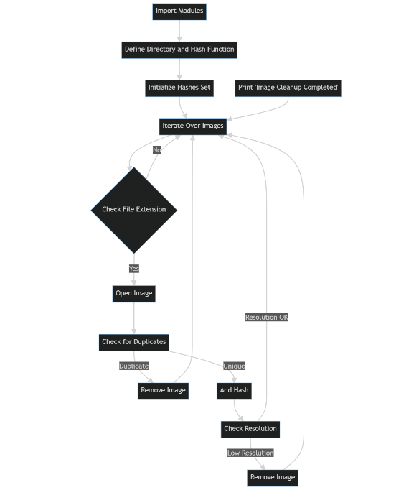

Figure 5 Algorithm diagram showing the data cleaning process.

While automated scripts are efficient for bulk cleaning, they lack the nuanced understanding required for more complex tasks. Therefore, a manual review of the dataset was conducted to:

* Remove images that were not relevant to the study, such as indoor images or natural landscapes devoid of architectural or vehicular features.
* Eliminate images with explicit faces directed towards the camera to adhere to privacy concerns.

The dataset underwent a rigorous validation process to ensure its quality and relevance for the study. This involved:

* Quality Checks: Each image was manually reviewed to confirm that it met the established criteria for dimensions and content.
* Validation Metrics: Although the study primarily focuses on qualitative aspects, basic validation metrics were employed to ensure the dataset's integrity, echoing the sentiment of "A Review on Data Cleansing Methods for Big Data" [48].

To further streamline the dataset and facilitate easier tracking and analysis, a custom script was developed to rename the images in each city-specific folder (Liverpool, Algiers, Tokyo). The renaming followed a numerical sequence, starting from 0000 and incrementing by one for each subsequent image. This systematic approach to naming not only made it easier to reference specific images but also aided in the automation of subsequent data processing steps. The renaming process is in line with best practices for data organization. We can see the Renaming Script Algorithm Diagram and a screenshot of a sample folder showing the renamed images in numerical sequence respectively Figure 6 & Figure 7 .

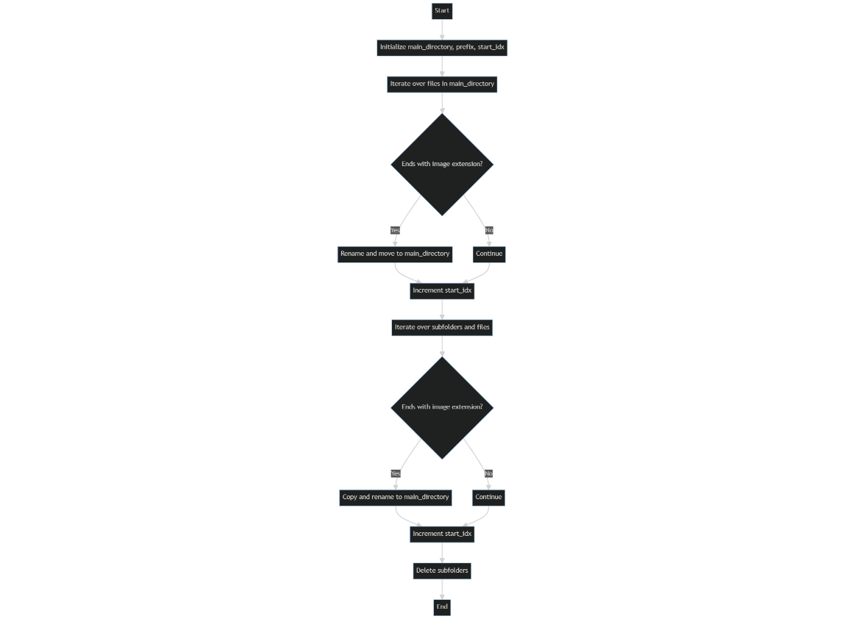

Figure 6 Algorithm Diagram showing the Rename script process.



Figure 7 A screenshot of a sample folder showing the renamed images in numerical sequence.

The data cleaning process was not without its challenges:

* **API Limitations:** The use of Flickr and Bing APIs for data collection came with rate limits, affecting the volume of data that could be collected in each time frame.
* **Manual Review:** The manual review process, although necessary, was time-consuming and introduced a subjective element to the data cleaning process, as highlighted by "Study on image data cleaning method of early esophageal cancer based on VGG_NIN neural network" [49].

After the rigorous cleaning process, the dataset was narrowed down to approximately 2,881 images, with each city—Liverpool, Algiers, and Tokyo—contributing around 30% of the total images Figure 8. This was in line with our initial aim for balanced representation across the three cities.

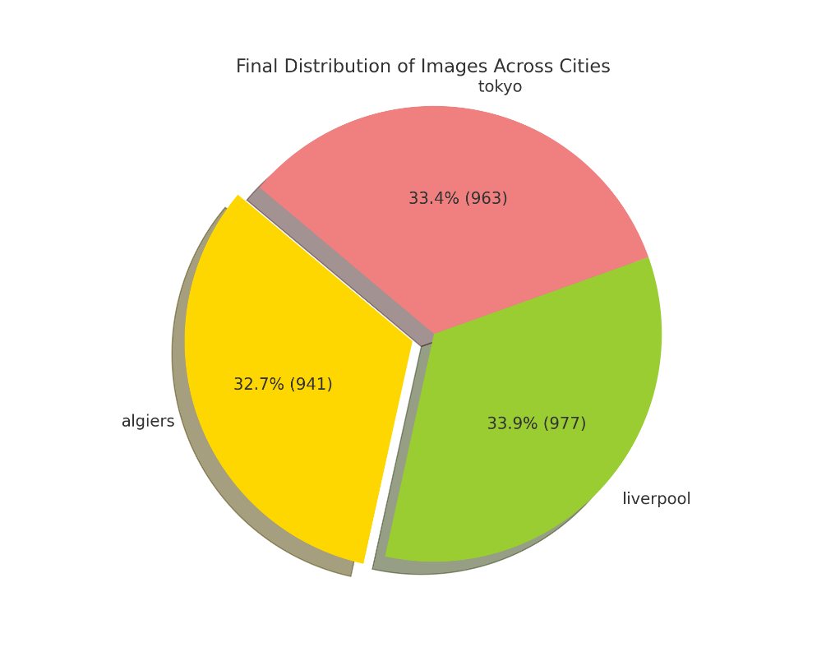

Figure 8 Pie chart showing the final distribution of images across the three cities.

#### Data Labeling

For data annotation, a combination of Amazon S3 and Label Studio was employed to create a robust and scalable annotation pipeline. Amazon S3 was utilized for data storage Figure 9, ensuring a secure and easily accessible data repository, while Label Studio was used for the actual annotation process.



Figure 9 Amazon S3 Bucket Used for Data Storage

The integration of these platforms enabled seamless data management and backup capabilities. After collecting the image data, it was uploaded to an S3 bucket. This provided several benefits:

* **Data Backup:** Ensured that all collected data was securely backed up.
* **Easy Access:** Facilitated quick access to data regardless of location.
* Scalability: Allowed for easy scaling of the data storage infrastructure as the project grew.

The S3 bucket was linked to Label Studio, enabling direct access to the stored images for annotation. In Label Studio, two types of annotations were primarily used: polygon labels and bounding box labels. Polygon labels were employed to annotate features with irregular shapes, such as weather conditions and architectural styles. This allowed for a more precise capture of the features in question. On the other hand, bounding boxes were used for annotating features that had more regular shapes, like vehicles, signs, and textual content.

To maintain consistency in the data format, bounding boxes were later computed from the polygon annotations during the post-annotation phase. This was crucial for standardizing the labeled data and making it easier to integrate into the deep learning model.



Figure 10 Labeled Photo of Tokyo

The data labeling process was intricate, requiring a high level of attention to detail. Due to the diversity of features present in each image, up to 30 annotations were made per image, increasing both the time required for labeling and the overall complexity of the data.

By leveraging the capabilities of Amazon S3 for data storage and Label Studio for data annotation, a scalable and efficient data labeling methodology was established. This approach was specifically tailored to the unique needs of this project, providing the flexibility to adapt as the project's requirements evolved.

Detailed Annotation Schema for Efficient Data Management and Training

Our annotation strategy was designed not only for data categorization but also to aid in more efficient model training. Utilizing a prefix-based labeling system facilitated the dynamic allocation of features to specific layers in our deep learning model. This not only streamlined the training process but also allowed for granular control over feature extraction and representation learning.

Here is a table summarizing the annotation schema:

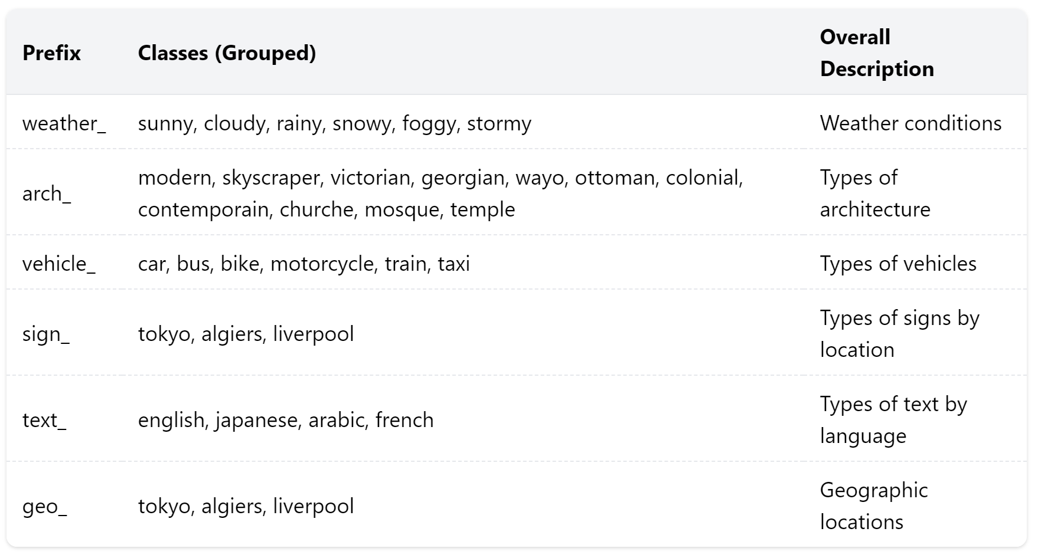

Figure 11 Overview of Prefix-Based Categories and Their Descriptions

The prefixed labels provided two key advantages during the model training process:

* **Layer-specific Feature Routing:** The prefixed labels helped us in specifying which features would be processed by which layers in our neural network. For instance, weather-related features could be processed by layers specialized in understanding natural scenes, while architecture-related features could be sent to layers optimized for structural recognition.
* **Ease of Feature Management:** The use of prefixes made it easier to manipulate and manage features during both the training and inference stages. This was particularly useful for quick feature ablation studies, where we could easily include or exclude specific sets of features to understand their impact on model performance.

By leveraging this detailed annotation schema in combination with advanced tools and cloud-based data storage solutions, we were able to establish a robust, scalable, and efficient methodology for data labeling and model training.

### Exploratory Data Analysis

Exploratory Data Analysis (EDA) is a cornerstone in the field of data science. It serves as a preliminary step for understanding complex datasets, such as the one used in this study. EDA helps in identifying patterns, anomalies, and key features that are crucial for subsequent machine learning models. According to a paper published in the 2021 6th International Conference on Communication and Electronics Systems, EDA is essential for deriving critical business insights and is a fundamental process for investigating data anomalies, missing data, and patterns [50].

The EDA techniques employed in this study aim to address the unique challenges posed by our dataset. These challenges include a variety of annotated features and geographical tags. Techniques such as distribution analysis, category co-occurrence heatmaps, and bounding box area comparisons are particularly relevant. These methods provide insights into how features are distributed across different geographical contexts, thereby aiding in feature engineering and model selection processes.

#### Distribution of Annotations Across Categories and Geographical Tags

Understanding the distribution of annotations across different categories and geographical tags is crucial for several reasons. First, it provides insights into the diversity and richness of the dataset. Second, it helps identify potential biases or imbalances that could affect the performance of machine learning models1. Lastly, it informs the feature engineering process, guiding the selection of relevant attributes for model training. To analyse the distribution, we employ bar plots and histograms, as these visual tools offer a straightforward way to compare the frequency of different categories and geographical tags [51]. For example, a bar plot can show the number of annotations for each category—such as vehicles, architecture, and weather conditions—across different categories and each city.

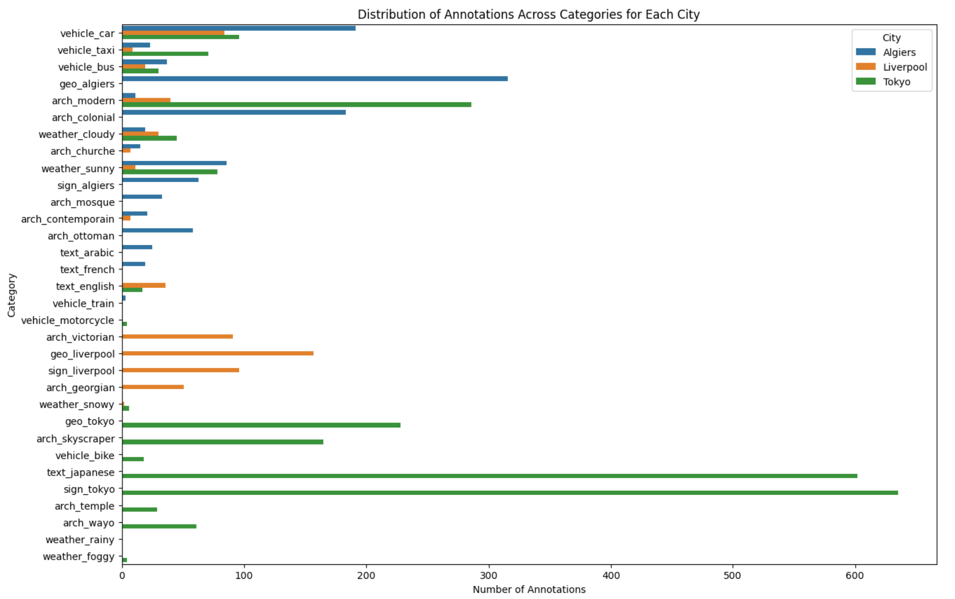

Figure 12 Bar Plot showing the Distribution of Annotations Across Categories for Each City.

Preliminary analysis reveals some interesting patterns. For instance, vehicle car elements are more frequently annotated in images from Algiers, while vehicle taxi annotations are more common in Tokyo. These insights are valuable for understanding how features are geographically distributed, which is essential for building robust machine learning models.

Interestingly, the class imbalance observed in categories like sign_tokyo and text_japanese is not merely a statistical issue but a meaningful characteristic of the dataset. This imbalance serves as a feature for geolocation-based models. For example, the high frequency of signs and Japanese text is indicative of Tokyo's urban landscape. Similarly, the imbalance in categories like weather conditions and types of vehicles also carries geographical significance. The absence or scarcity of certain categories can be as informative as their presence, offering additional layers of features for machine learning models.

#### Addressing Imbalances

The presence of class imbalances in categories such as sign_tokyo, text_japanese, and various types of vehicles and weather conditions raises the question of whether data balancing techniques should be employed. After careful consideration, we have decided against balancing the dataset for several compelling reasons:

* **Geographical Indicators:** Categories like sign_tokyo and text_japanese are not merely imbalanced classes but serve as geographical indicators. Their prevalence or absence can provide valuable insights into the geolocation of an image.
* **Informative Imbalances:** Similarly, imbalances in weather conditions or types of vehicles are not statistical anomalies but reflect real-world variations. For instance, the higher frequency of sunny weather images could indicate a geographical area where sunny days are more common.
* **Feature Significance:** The absence of certain features can be as informative as their presence. For example, the lack of motorcycle annotations could indicate a region where motorcycles are less commonly used, which itself is a useful feature for geolocation.
* **Model Robustness:** Modern machine learning algorithms are often robust to class imbalances and can be fine-tuned to handle them effectively.

Given the informative nature of the imbalances in our dataset, we have opted for a more nuanced approach that preserves the integrity and richness of the data, thereby enabling more accurate and insightful analyses.

#### Distribution of Annotations per Image

The number of annotations per image is another critical aspect to consider in our EDA. This metric can vary significantly across the dataset, affecting both the computational complexity and the model's ability to generalize. Understanding this distribution is essential for optimizing the machine learning algorithms and ensuring that they can handle images with varying numbers of annotations effectively. We use histograms to visualize the distribution of annotations per image. This graphical representation allows us to quickly identify the range and frequency of annotation counts across the dataset Figure 13.

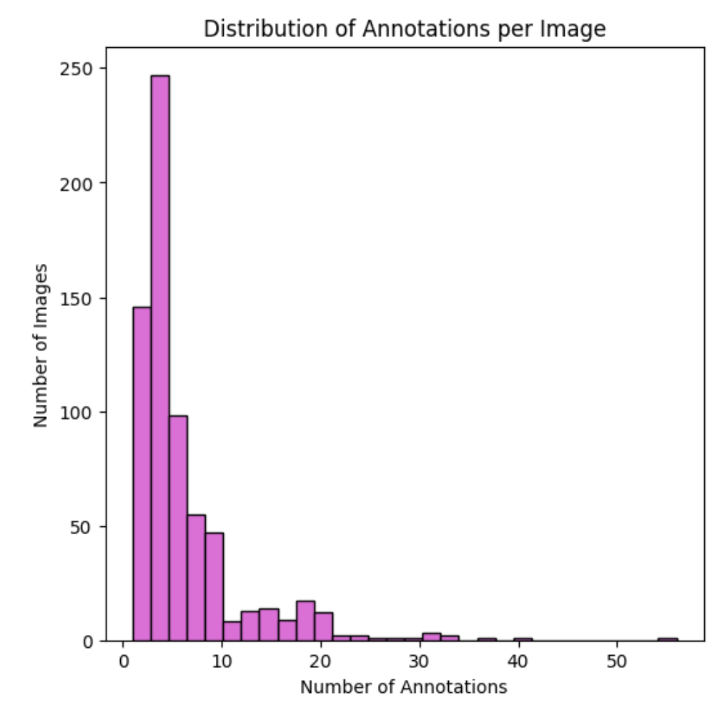

Figure 13 Distribution of Annotations per Image.

Initial findings indicate that most images have a moderate number of annotations, there are outliers with exceptionally low counts. This is particularly important for machine learning models that are sensitive to input size, such as convolutional neural networks.

#### Visualizing a Sample Image with Annotations

Visualizing the actual images along with their annotations is not just a supplementary step but a core part of understanding the complexity and diversity of the dataset. This approach aligns with the insights provided by Jan Majewski in his article on improving visualization readability, emphasizing that effective annotations can significantly enhance the clarity and depth of visual data representations [52]. To provide a comprehensive view of the dataset, we randomly select a sample image and overlay it with its corresponding annotations. These annotations include bounding boxes and category labels, serving as a microcosm of the dataset. This methodology is consistent with best practices in data visualization, which advocate for the use of meaningful text and annotations to make the data easier to interpret across different teams[52].

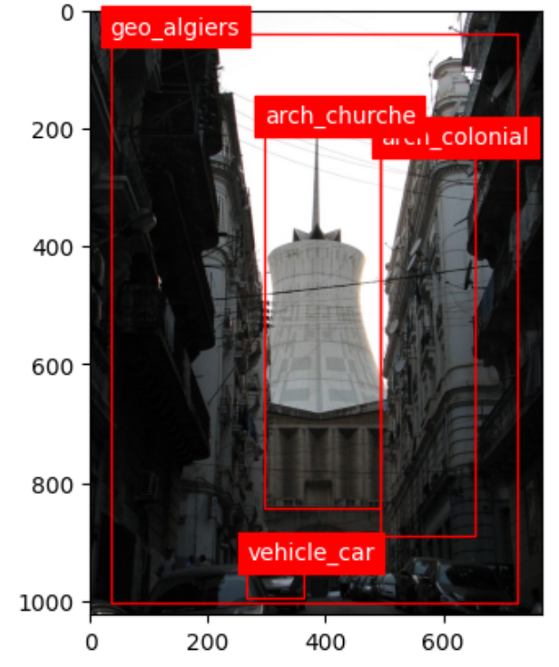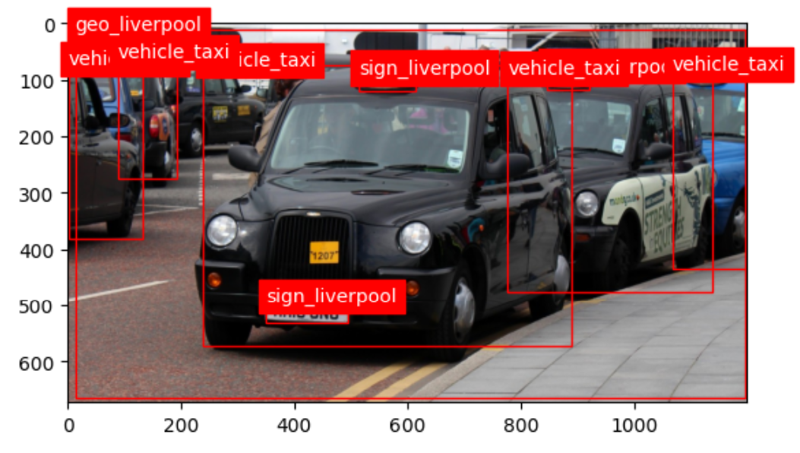

Figure 14 Visualizing images along with their annotations.

The sample image serves as a case study, revealing multiple layers of complexity. For example, it shows how different categories like vehicles, buildings, and weather conditions co-exist in a single frame. This complexity is not just a challenge but also an opportunity, as it underscores the need for a machine learning model that can handle multi-label classification. The importance of understanding this complexity is echoed in the literature, emphasizing that the quality of a model's output is highly dependent on the quality of its input. Given the diversity and complexity of annotations in a single image, our machine learning model must be designed for multi-label classification. Furthermore, the model should be robust enough to differentiate between closely situated or overlapping annotations. This requirement is in line with the understanding that capturing the complexity of the data is the first step toward building a model that can handle it effectively.

#### Category Co-occurrence Heatmap

Understanding the relationships between different categories is a cornerstone for building robust machine learning models. Heatmaps serve as a powerful tool for this purpose, allowing us to visualize how frequently different categories appear together in the same image[53]. To construct this heatmap, we use a co-occurrence matrix where each cell represents the frequency of co-occurrence of two categories in the dataset. This visualization method is particularly relevant for multi-label classification tasks.

The heatmap reveals patterns specific to the dataset. For example, images tagged with 'geo_algiers' often appear with annotations related to specific types of architecture or vehicles. These patterns are not just interesting but also crucial for feature engineering and model selection. The use of text-mined co-occurrence features can further enrich this analysis, providing additional context for each category[54].

Understanding these relationships can significantly influence the architecture of the machine learning model. For instance, if two categories frequently appear together, the model can be designed to leverage this relationship, thereby improving both its accuracy and efficiency.

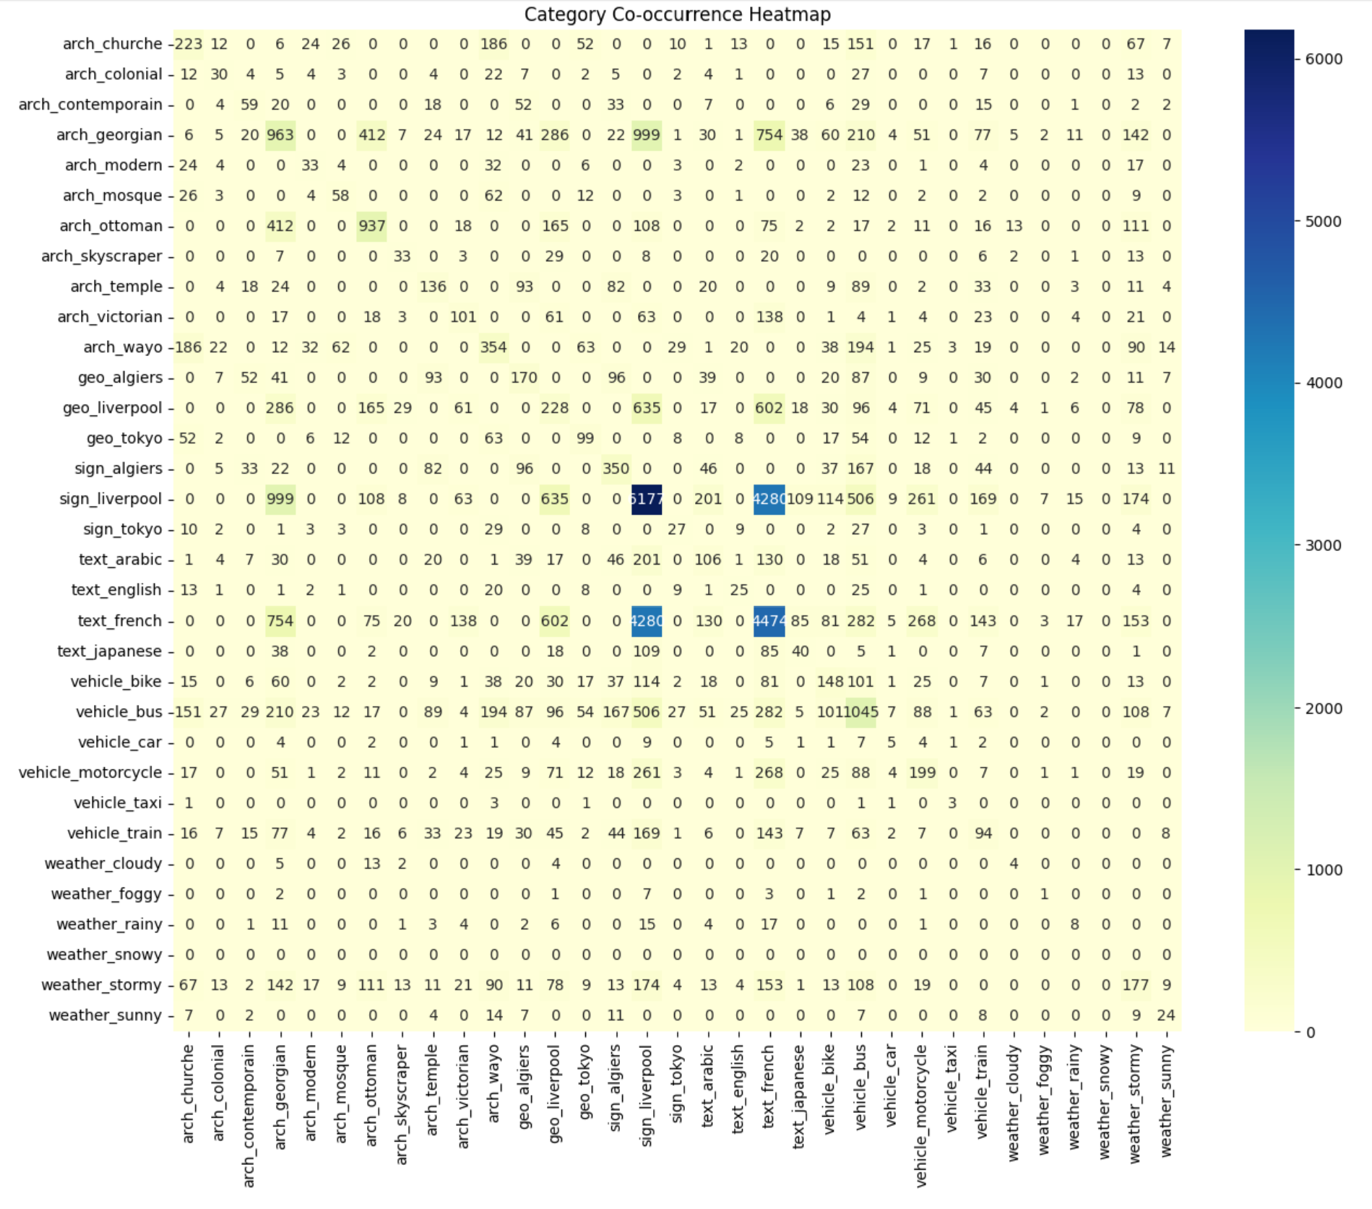

Figure 15 Category Co-occurrence Heatmap.

* **Architectural Styles and Geographical Tags:** The co-occurrence of architectural styles like 'arch_georgian' and 'arch_ottoman' with geographical tags like 'geo_liverpool' and 'geo_algiers' is noteworthy. This suggests that certain architectural styles are more prevalent in specific geographical locations, which could be a significant feature for the machine learning model.
* **Weather Conditions and Geographical Tags:** The table shows that 'weather_stormy' has a high co-occurrence with architectural styles like 'arch_georgian'. This could indicate that certain weather conditions are more common in areas with these architectural styles, providing another layer of information for the model.
* **Vehicles and Geographical Locations:** The co-occurrence of 'vehicle_motorcycle' and 'vehicle_bus' with geographical tags like 'geo_liverpool' and 'geo_algiers' suggests that the type of vehicles commonly found in these locations varies. This could be useful for the model to understand the geospatial context better.
* **Complex Interactions:** Categories like 'arch_ottoman' and 'weather_stormy' co-occur frequently, suggesting complex interactions between architectural styles and weather conditions. Understanding these can help in designing a model that can handle such complexities.

**Geographical Indicators:** geo_liverpool and arch_georgian have a co-occurrence of 286, indicating that Georgian architecture is quite common in Liverpool.

geo_algiers and arch_contemporain have a co-occurrence of 52, suggesting that contemporary architecture is notable in Algiers.

The analysis of category co-occurrence through a heatmap and accompanying visualizations provides invaluable insights into the intricate relationships between different annotation categories within the dataset. These relationships are not just statistical artifacts but offer a deeper understanding of the geospatial context, architectural styles, vehicle types, and weather conditions that co-exist in the images. Understanding these co-occurrences is not merely an academic exercise but a critical step in feature engineering and model selection. It allows us to architect machine learning models that can leverage these relationships for better accuracy and efficiency. The insights gained also pave the way for more focused error analysis and fine-tuning of the model in future iterations.

In summary, the category co-occurrence analysis serves as a cornerstone for building robust, context-aware machine learning models, thereby enhancing both their predictive power and interpretability [55]

### Data Augmentation

Data augmentation is a pivotal strategy in the training of deep learning models, particularly for object detection. It artificially inflates the training dataset by applying a variety of transformations to both the original images and their corresponding labels. This practice enhances the model's generalization capabilities, a point emphasized in a comprehensive review by Kaur et al. [56]. I utilized a range of data augmentation techniques in my study, such as rotation, flipping, and scaling. These are standard practices in object detection and have been empirically proven to boost model performance [57]. The approach involved augmenting pre-labeled data, adjusting the bounding boxes to align with the transformed images. This method is more accurate than first augmenting the data and then labeling it, which could introduce errors [56]. Initially, the augmentation pipeline included brightness and contrast adjustments. However, these were later excluded as they introduced bias, particularly since the model architecture is sensitive to color-based features [58]. In setup, the augmented data is generated on-the-fly and fed to the model in batches during training. This is not only storage-efficient but also effective in object detection tasks [57].

### Model Architecture

#### Object Detection Model

The architecture of the object detection model is built upon Faster R-CNN with a ResNet-50 backbone and a Feature Pyramid Network (FPN). Faster R-CNN is renowned for its real-time object detection capabilities and its effectiveness in handling various object scales[59].

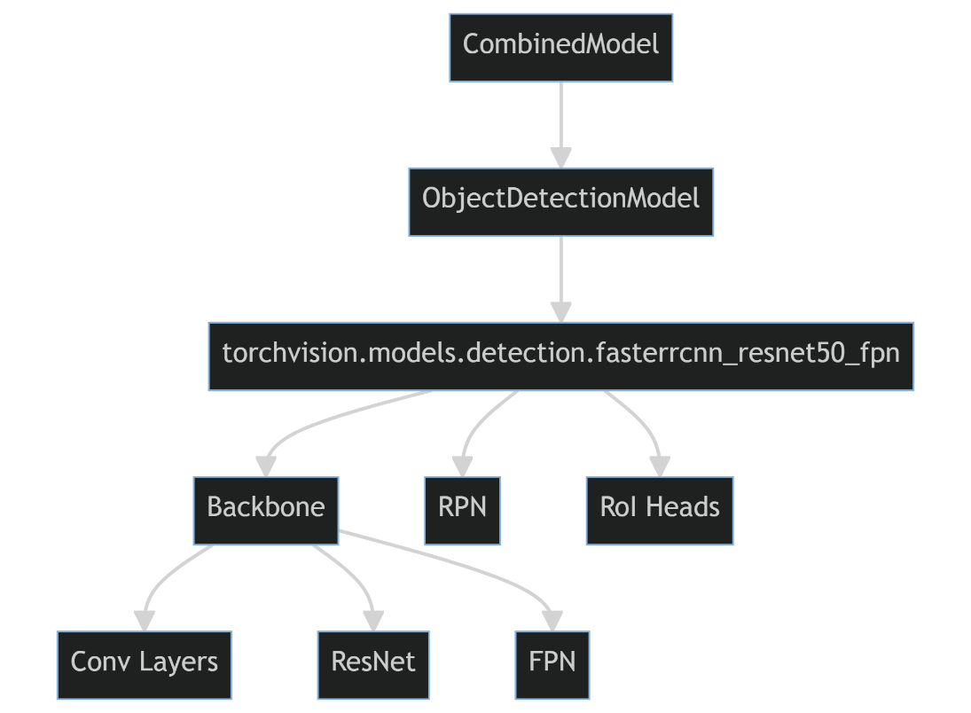

Figure 16 Faster R-CNN Diagram.

The Region of Interest (ROI) heads in the Faster R-CNN model has been customized to better suit the specific use-case. The original classifier was replaced with a Fast R-CNN predictor, allowing the model to be fine-tuned for our 33 unique object categories. The model's forward method serves dual purposes: it computes the loss during training and outputs object detections during inference. This design choice streamlines the transition between training and inference, making the model more versatile and easier to deploy. The choice of Faster R-CNN with a ResNet-50 backbone and FPN was motivated by the need for a robust and versatile object detection model. The ROI heads were specifically modified to cater to the unique categories in dataset. The dual functionality of the forward method simplifies the training and inference process, making the model more user-friendly. The object detection model serves as the cornerstone for the combined mode complex architecture, which aims to perform hierarchical classification and geo-prediction based on the detected objects.

#### Feature Extraction

After object detection, we calculate additional geometric features such as aspect ratio, area, perimeter, compactness, and extent for each bounding box. These features provide more context about the shape and size of the detected objects, which can be crucial for subsequent tasks like hierarchical classification and geo-prediction [60]. In addition to geometric features, we also extract visual features such as mean color, texture (utilizing Local Binary Pattern), and edge count (leveraging the Sobel operator) for each detected object. These features encapsulate the visual attributes of the objects, which are pivotal for scene understanding. The geometric and visual features are then concatenated to form a comprehensive feature vector for each object. This aggregated feature vector is then used as the input for the hierarchical classification layer. The inclusion of additional geometric and visual features aims to enrich the feature set available for model learning. The selection of these specific features is backed by their demonstrated effectiveness in a range of computer vision tasks[59]. Aggregating these features into a single vector enables the model to learn intricate relationships between different feature types, which is crucial for achieving our goal of geo-prediction based on a comprehensive understanding of the scene.

#### Hierarchical Classification Layer

The hierarchical classification layer is designed with multiple sub-layers, each specializing in classifying objects into distinct categories such as architecture, geo-location, signs, text, vehicles, and weather. Each sub-layer is a fully connected linear layer, the dimensions of which are tailored to the number of classes in each category Figure 17. This hierarchical structure is particularly effective for handling the complexity and variety of features extracted from detected objects [61].

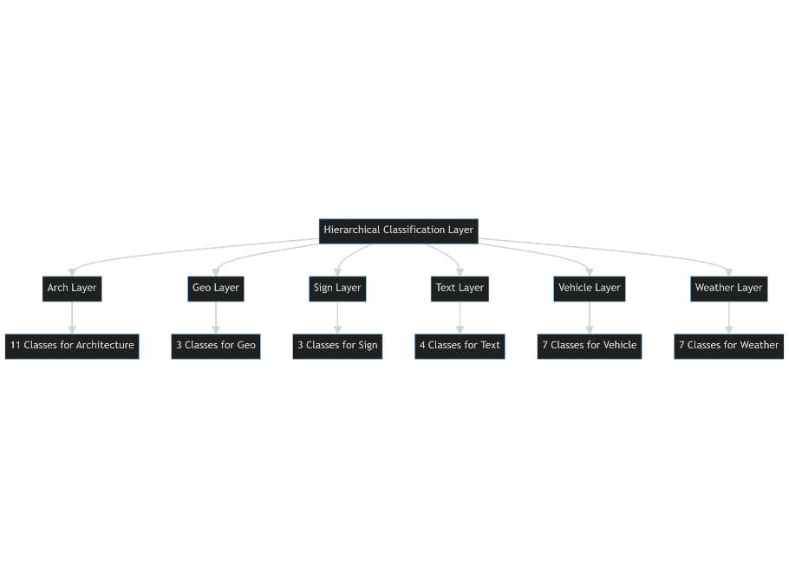

Figure 17 Diagram of the Hierarchical Layer

An attention mechanism is employed to dynamically weigh the importance of different feature categories for the final geo-prediction. This mechanism allows the model to focus on features that are most relevant for geo-prediction, such as unique architectural styles specific to certain locations. The attention mechanism's role in dynamically adjusting the importance of features is well-documented in the literature [62]. Adding another layer to the model, the Geo-Prediction Layer serves as the final part of the hierarchical classification layer. It takes the aggregated features, weighted by the attention mechanism, to make the ultimate prediction about the geo-location of the scene. This layer is specifically designed to make accurate and context-aware geo-predictions, aligning with our primary objective [63][43].

The hierarchical structure is designed to manage the complexity and diversity of features from the detected objects effectively. Specialized sub-layers for each category enable the model to learn nuanced patterns within each, crucial for accurate geo-prediction[61].

The attention mechanism is vital for our primary goal of geo-prediction. It allows the model to adjust the importance of different features based on the scene's context, such as the presence of a specific architectural style being a strong indicator of a particular location[62].

The Geo-Prediction Layer is the culmination of all previous layers, designed to make the final geo-location prediction based on the weighted features. This design choice is in line with our primary objective and enables the model to make more accurate geo-predictions[63][43].

#### Geo-Prediction Layer

This layer serves as the final part of the hierarchical classification layer. It takes the aggregated features, weighted by the attention mechanism, to make the ultimate prediction about the geo-location of the scene.

* Context-Aware Predictions: This layer is specifically designed to make accurate and context-aware geo-predictions, aligning with the primary objective of the model.

#### Combined Model Architecture

The Object Detection Model serves as the foundation of the entire architecture. It employs a Faster R-CNN model with a ResNet-50 backbone and FPN for real-time object detection. The model is initialized with pre-trained weights and fine-tuned for 33 unique object categories.

Mathematical Representation:

$$Fobj​(I)=\{(b1​,c1​),(b2​,c2​),…,(bn​,cn​)\}$$

Operational Flow:

* Input: Raw image $I$
* Output: Bounding boxes $bi$ ​ and class labels $ci$

​

#### Feature Extraction

This phase calculates additional geometric and visual features for each bounding box detected. These features include aspect ratio, area, perimeter, compactness, extent, mean color, texture, and edge count.

Mathematical Representation:

$$vi​=Ffeat​(bi​,ci​)=[a1​,a2​,…,am​]$$

Operational Flow:

* Input: Bounding boxes and class labels from $Fobj$

​
* Output: Feature vector $vi$ ​ for each object

#### Hierarchical Classification Layer

This layer is designed with multiple sub-layers, each specializing in classifying objects into distinct categories such as architecture, geo-location, signs, text, vehicles, and weather.

Mathematical Representation:

$$Fhier​(v)=softmax(Whier​⋅v+bhier​)$$

Operational Flow:

* Input: Feature vectors $vi$

​
* Output: Class probabilities for each category

#### Attention Mechanism

An attention mechanism is employed to dynamically weigh the importance of different feature categories for the final geo-prediction.

Mathematical Representation:

$$A(v)=softmax(Watt​⋅v)$$

Operational Flow:

* Input: Feature vectors $vi$

​
* Output: Attention weights

#### Geo-Prediction Layer

This is the final layer designed to make accurate and context-aware geo-predictions based on the aggregated features, weighted by the attention mechanism.

Mathematical Representation:

$$Fgeo\left(v\right)=Wgeo∙\left(A\left(v\right)⨀v\right)+bgeo$$

Operational Flow:

* Input: Aggregated features
* Output: Geo-location predictions

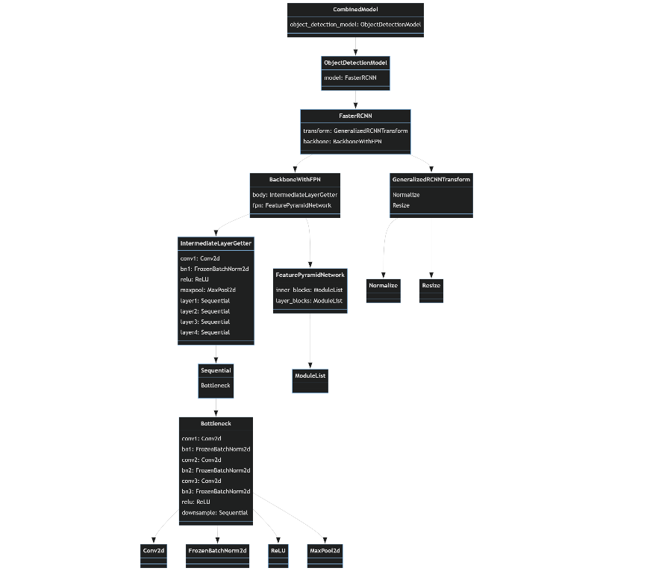

Figure 18 Combined Model Architecture Diagram.

### Model Training

#### Computational Resources

The training was conducted on a high-performance NVIDIA A100 GPU with 50 GB of VRAM and 50 GB of RAM. This choice of hardware was crucial for handling the computational complexity of the model. The A100 GPU is designed for data-intensive tasks and offers a significant speedup in tensor computations, making it an ideal choice for deep learning applications[64]. The training was further facilitated by Google Colab Pro, a cloud-based platform that provides access to specialized hardware resources, thereby accelerating the model training process.

#### Data Loading and Preprocessing

The DataLoader from PyTorch's utility was employed to load the training dataset. The batch size was set to 10, a decision influenced by the computational capabilities of the A100 GPU. Unlike typical GPUs, the A100 allows for larger batch sizes without compromising on speed or performance, thus enabling more stable and faster convergence3. The images were not resized before feeding them into the model, as Faster R-CNN with a ResNet-50 backbone is capable of handling varying image sizes internally[59].

#### Optimization Algorithm

The Stochastic Gradient Descent (SGD) optimizer was used with a learning rate of 0.005, momentum of 0.9, and weight decay of 0.0005. The choice of SGD was motivated by its proven effectiveness in training deep neural networks[65]. The learning rate was carefully selected after a series of experiments, as it plays a crucial role in the speed and stability of the training process [66]. The momentum term helps in overcoming local minima and speeds up convergence[67]. Weight decay acts as a regularization term to prevent overfitting.

#### Learning Rate Scheduling

A learning rate scheduler was employed to adjust the learning rate during training. Specifically, a StepLR scheduler was used, which decays the learning rate by a factor of 0.1 every 10 epochs. This approach is known to result in better generalization and faster convergence [68].

#### Training Loop and Loss Function

The training loop was designed to be robust and efficient. Each epoch involves a forward pass where the loss is computed, followed by a backward pass for gradient computation and parameter update. The loss function is a composite of several individual losses, each corresponding to different aspects of the model, such as object detection and hierarchical classification[69].

#### Epochs and Early Stopping

The model was initially set to train for 100 epochs. However, an early stopping mechanism was implemented to halt the training if the model's performance plateaued, thereby saving computational time and resources. The early stopping mechanism was triggered after 40 epochs, indicating that the model had reached a point where further training would not significantly improve its performance. This is consistent with the literature, which suggests that early stopping can act as a form of regularization, preventing the model from overfitting the training data[70].

#### Time Complexity

The total training time was approximately 3.5 to 4 hours. This is relatively efficient given the complexity of the model and the high-dimensional feature space it operates in. The efficiency can be attributed to the computational capabilities of the A100 GPU and the optimization techniques employed, such as learning rate scheduling and early stopping[71].

The hyperparameters were carefully selected to optimize the model's performance. A batch size of 10 was chosen to leverage the high-performance capabilities of the A100 GPU, allowing for faster and more stable training[72]. The learning rate and other optimizer parameters were set based on empirical studies that highlight their effectiveness in deep learning applications [73]. The training process was meticulously designed to be robust, efficient, and effective. Utilizing state-of-the-art computational resources and optimization techniques, the model was trained to perform complex tasks like hierarchical classification and geo-prediction based on object detection. The early stopping mechanism, along with other techniques like learning rate scheduling, contributed to the model's high efficiency and performance.

### Model Inference

The inference stage is the culmination of the machine learning pipeline, where the trained model is deployed to make predictions on unseen data. In the context of our research, the model's primary objective during inference is not object detection per se, but rather geo-prediction. This section delves into the intricacies of the inference process, detailing the computational resources, algorithms, and methodologies employed [74].The inference was conducted on an A100 GPU with 50GB of VRAM and 50GB of RAM, mirroring the hardware configuration used during the training phase. The A100 GPU's high-performance capabilities are essential for real-time inference, a critical requirement for applications that demand immediate decision-making.

#### Object Detection and Feature Extraction

**T**he model employs Faster R-CNN with a ResNet-50 backbone and FPN for object detection. However, it's crucial to note that the bounding boxes are not displayed during inference. The primary role of the object detection layer is to identify regions containing potential features that are significant for geo-prediction. These regions serve as the foundation for subsequent feature extraction, which includes both geometric and visual attributes [59].

#### Hierarchical Classification

Once the features are extracted, they are passed to the hierarchical classification layer. This layer categorizes the detected objects into various domains such as architecture, geo-location, signs, text, vehicles, and weather. The softmax activation function is applied to the raw output scores to convert them into probabilities, thereby enhancing the classification's accuracy [61].

#### Geo-Prediction

The goal of the inference process is geo-prediction. The model employs an attention mechanism to dynamically weigh the importance of different feature categories. These weighted features are then used to predict the geographical location of the scene. Importantly, the output presented to the user is solely geo-prediction, superimposed directly onto the image, without any bounding boxes.

#### Inference Time

The computational power of the A100 GPU enables real-time inference, a significant advantage for applications requiring immediate responses, such as real-time mapping or emergency response systems. The model's inference process is meticulously designed to be both robust and efficient. It leverages state-of-the-art computational resources and machine learning algorithms to perform complex tasks like object detection, hierarchical classification, and geo-prediction seamlessly. The result is a model that aligns perfectly with the research objectives, providing accurate geo-predictions without the need for displaying object bounding boxes.

### Evaluation metrics

The evaluation of machine learning models is a critical step in the development pipeline. It provides insights into the model's performance and its ability to generalize to unseen data. In the context of our research, the primary objective is geo-prediction, not object detection. Therefore, the choice of evaluation metrics is tailored to align with this specific goal. This section elaborates on the selected metrics and justifies their relevance to the research objectives.

#### Why Not mAP?

Mean Average Precision (mAP) is a commonly used metric for evaluating object detection models. However, it is not employed in this research. The reason is straightforward: the end goal of our model is not object detection but geo-prediction. While object detection serves as an intermediate step in our pipeline, it is not the final output presented to the user. Therefore, using mAP would not provide a meaningful measure of the model's effectiveness in achieving its primary objective of accurate geo-prediction.

#### Training Loss and Epoch Loss

Training loss and epoch loss serve as the foundational metrics for monitoring the model's learning progress. A decreasing trend in these metrics over successive epochs is indicative of the model successfully learning to map the input features to the target labels. These metrics are particularly useful during the training phase for diagnosing issues such as overfitting or underfitting [75].

#### Validation Loss

Validation loss is crucial for assessing the model's generalization capability. A model that performs well on the training data but poorly on the validation data is likely overfitting. Monitoring the validation loss alongside the training loss provides a more holistic view of the model's performance [76].

#### Accuracy, Recall, F1 Score, and Precision

Accuracy is a straightforward metric that measures the proportion of correctly classified instances. However, accuracy alone can be misleading, especially in imbalanced datasets. Therefore, it is supplemented with Recall, F1 Score, and Precision.

* Recall: Measures the model's ability to correctly identify all relevant instances. High recall is essential for applications where failing to identify a true positive is more costly than falsely identifying a negative.
* F1 Score: The harmonic mean of Precision and Recall, providing a balanced measure of the model's performance.
* Precision: Measures the proportion of true positives among the instances classified as positive. High precision is crucial when the cost of a false positive is high.

The chosen metrics align closely with the research objectives, focusing on the model's ability to make accurate geo-predictions. They offer a comprehensive view of the model's performance, considering various facets like generalization, precision, and recall.

# 

## Evaluation

### Performance Metrics

#### Accuracy

The evaluation of the model's performance is a critical aspect of any machine learning project. In our case, the focus is on geo-prediction, and thus the metrics are tailored to evaluate the model's proficiency in this specific task. The commonly used metric for object detection, mean Average Precision (mAP), was not employed as the primary objective of our model is not object detection but geo-prediction. The model was trained for 40 epochs, after which early stopping was triggered. The training and validation accuracies over these epochs are plotted below:

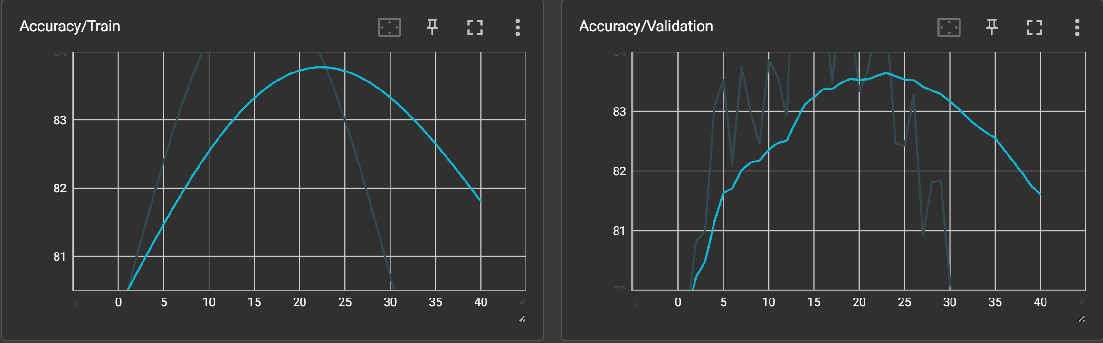

Figure 19 Training and Validation Accuracy over Epochs

Training accuracy started at approximately 80.5% and increased to a peak of around 84.99% at epoch 16. After this point, the accuracy started to decline, which is indicative of the model beginning to overfit. This is further corroborated by the validation accuracy trends. The early stopping mechanism halted the training at epoch 40, where the training accuracy was approximately 76.22%.

The validation accuracy started at around 79.63% and reached its peak at approximately 86.60% at epoch 14. After this point, the validation accuracy started to decline, which is a strong indicator that the model was beginning to overfit to the training data. The early stopping mechanism triggered at epoch 40, where the validation accuracy was around 77.17%.

#### Loss

The losses for both the training and validation sets show a decreasing trend, which is generally indicative of successful learning. However, the graphs reveal some nuances:

* **Fluctuating Training Loss:** After an initial drop, the training loss shows some fluctuations, suggesting that the model might be struggling to generalize the complex features for geo-prediction. This is consistent with the model's architecture, which is highly complex and optimized for object detection tasks.
* **Validation Loss Trends:** The validation loss seems to decrease initially and then plateaus, suggesting that the model is not overfitting but may have reached a point of minimal improvement given the current dataset and features.

The fluctuating nature of these metrics indicates potential overfitting and raises questions about the model's ability to generalize well to new, unseen data.

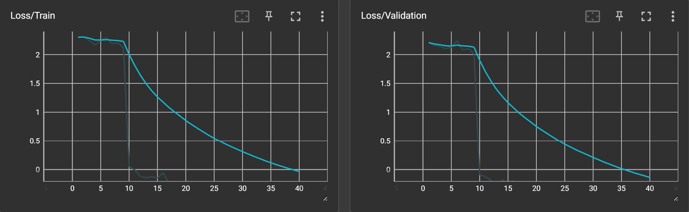

Figure 20 Training and Validation Loss over Epochs

#### Recall

The Recall metrics for Tokyo, Liverpool, and Algiers exhibit variability across epochs, as shown in the corresponding graphs. This variability can be attributed to several factors:

* **Feature Complexity:** Given the multi-faceted features like architecture, vehicles, and signs, the model may find it challenging to correctly identify all relevant instances affecting Recall.
* **Model Sensitivity:** The attention mechanism in the model, while effective for object detection, may not be finely tuned for geo-prediction tasks, which require recognizing subtler cues.
* **Data Diversity:** The dataset captures a wide range of features, including architecture and weather conditions, which could introduce noise into the model, thereby affecting its Recall performance.

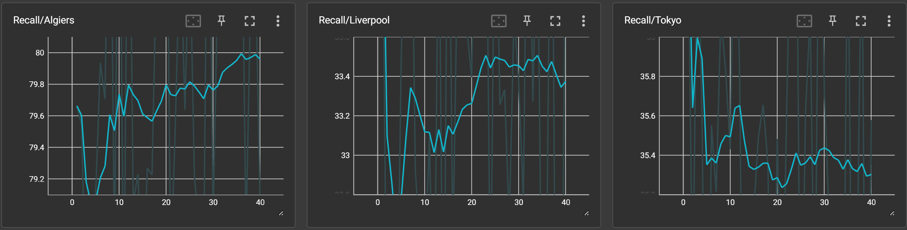

Figure 21 Recall Metrics for the three cities (Algiers, Liverpool and Tokyo).

#### Precision

Like Recall, Precision metrics also fluctuated across epochs for each city. The lower values can be explained by:

* **Model Architecture:** The Faster R-CNN model with a ResNet-50 backbone and Feature Pyramid Network (FPN) was optimized for object detection but not specifically for geo-prediction.
* **False Positives:** The model may identify irrelevant features as significant, affecting the proportion of true positives.

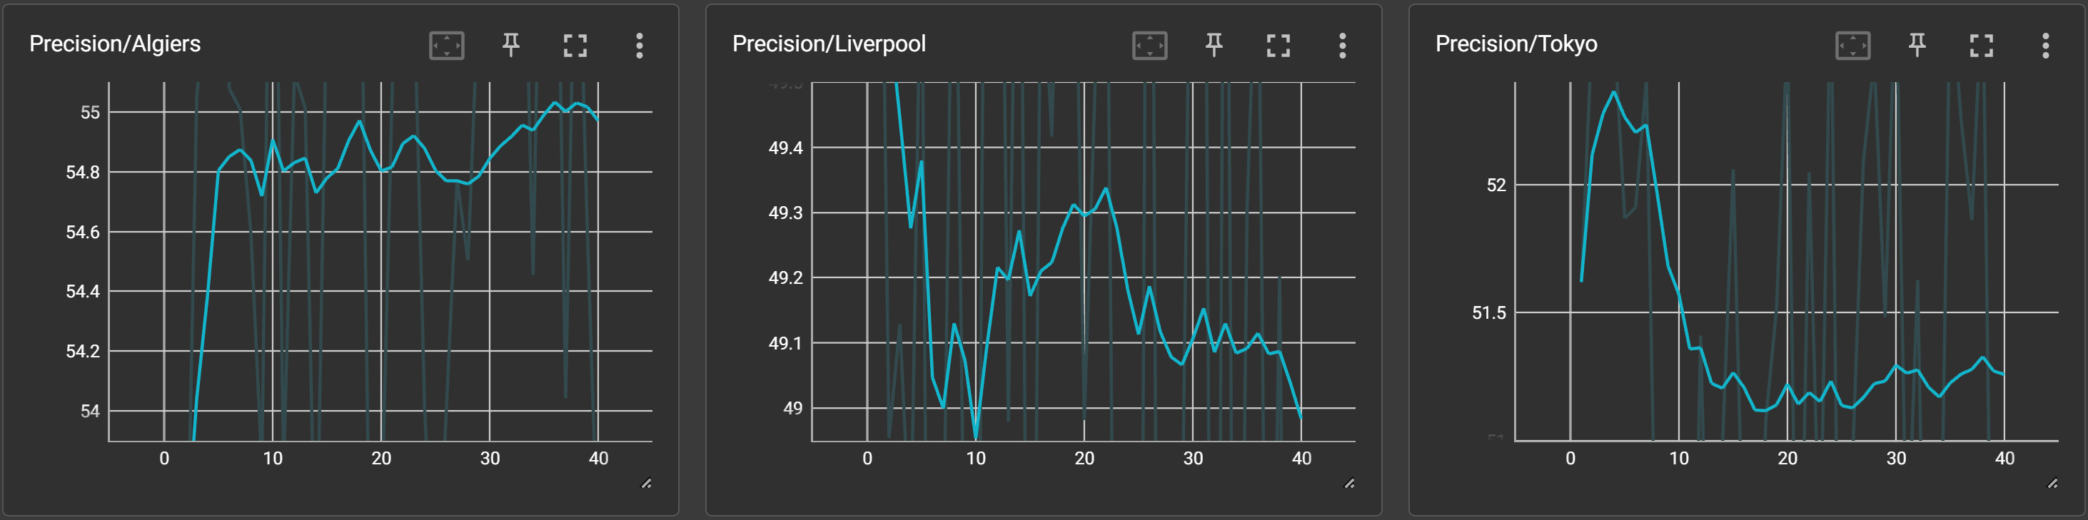

Figure 22 Precision Metrics for the three cities (Algiers, Liverpool and Tokyo)

#### F1 Score

The F1 Score, a balanced measure of Precision and Recall, also showed variability. Given that F1 Score is the harmonic mean of Precision and Recall, its fluctuation is a direct result of the variability in these two metrics. Lower F1 Scores are indicative of the challenges in achieving a balanced performance for geo-prediction tasks.

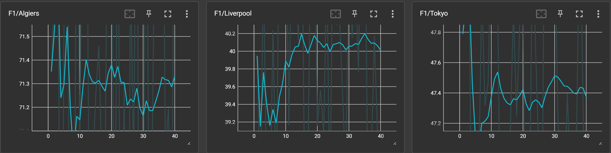

Figure 23 F1 Score Metrics for the three cities (Algiers, Liverpool and Tokyo)

The evaluation metrics suggest room for improvement. These limitations offer a roadmap for future research:

* **Feature Engineering:** More advanced feature extraction techniques could improve the model's performance.
* **Data Augmentation:** Employing more robust data augmentation strategies could help the model generalize better to unseen data.
* **Hyperparameter Tuning:** Further fine-tuning of model parameters may yield better results.
* **Dataset Size:** Given the complexity of the model architecture and the multi-dimensionality of the features, a larger and more diverse dataset is likely required for the model to realize its full potential. Expanding the dataset could address the existing limitations in Recall, Precision, and F1 Score by providing the model with a broader feature space to learn from.

While the model shows promise in its ability to geolocate images based on multiple features, these results indicate the complexity and challenge of achieving high performance in such a multi-dimensional problem space.

### Inferencing

To evaluate the model's capabilities for real-world application, inferencing was performed on a set of 15 never-seen-before images, with 5 images from each of the cities Algiers, Liverpool, and Tokyo. The images were arranged in a 3x5 grid, and the model was tasked with geolocating each image to its respective city.

#### Results

The inferencing results were as follows Figure 24:

* **First Row (Algiers Images):** The model predicted the locations as Liverpool, Algiers, Liverpool, Algiers, Algiers.
* **Second Row (Liverpool Images):** The model's predictions were Liverpool, Algiers, Liverpool, Tokyo, Algiers.
* **Third Row (Tokyo Images):** The model inferred the locations as Algiers, Liverpool, Tokyo, Algiers, Liverpool.

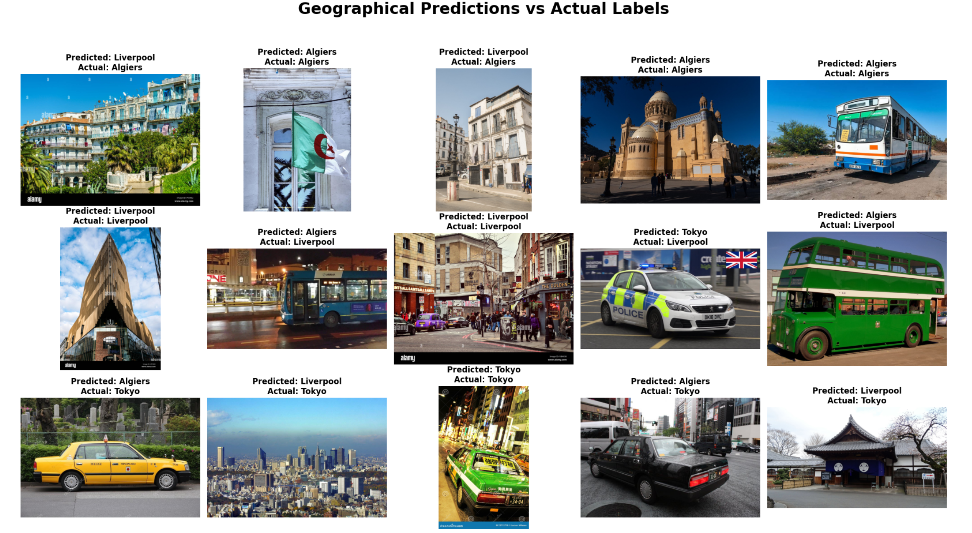

Figure 24 Inferencing Results on Never-Seen-Before Images from Algiers, Liverpool, and Tokyo

#### Discussion

The inferencing results indicate a mixed performance:

* **Algiers:** The model was able to correctly identify 3 out of 5 images, indicating a reasonable capability to recognize features specific to Algiers.
* **Liverpool:** The model's performance was less consistent for Liverpool, correctly identifying only 2 out of 5 images. This could be due to the model's sensitivity to the multi-faceted features that are more common in Liverpool.
* **Tokyo:** The model correctly identified only 1 out of 5 Tokyo images. This suggests that the model may be struggling with the high feature diversity present in Tokyo's urban environment.

#### Implications

The results suggest that while the model has some capability to generalize to new, unseen data, there are clear limitations:

* **Feature Overlap:** The misclassifications, particularly for Liverpool and Tokyo, suggest that the model may be confusing features that are common across different cities.
* **Model Robustness:** The varying performance across different cities indicates that the model may require further tuning to be robust to a diverse set of geographical features.

This inferencing exercise provides valuable insights into the model's real-world applicability and areas for improvement, laying the groundwork for future research endeavors.

### Summary

Our evaluation casts a comprehensive and nuanced light on the performance of the image-based geolocation model, an essential step given its real-world application prospects. Central to this evaluation is the model's complex architecture, which integrates Faster R-CNN, a ResNet-50 backbone, and a Feature Pyramid Network (FPN). While this complexity manifests in promising metrics across Recall, Precision, and F1 Score, it also introduces challenges that become evident when scrutinizing the data. We observe these challenges most markedly across the test cities of Tokyo, Liverpool, and Algiers. Although the metrics show potential, they fluctuate significantly, reflecting the model's struggle to consistently interpret the multi-faceted features unique to each city. This inconsistency raises the question of whether the model is truly generalizable, a concern that is further underscored by thr analysis of training and validation loss. Despite a downward trend indicating learning, the loss metrics reveal fluctuations that suggest potential overfitting and raise questions about the model's adaptability to unseen data.

To investigate this adaptability, we conducted an inferencing experiment using never-seen-before images from each test city. The results were mixed but informative. While the model demonstrated some capacity to generalize its learning, the frequent misclassifications, especially across geographically diverse settings, point toward its limitations. These findings resonate with the earlier metrics, adding a layer of coherence to the evaluation. Such coherence not only confirms the model's current constraints but also illuminates the path forward. It underscores the necessity for a multi-pronged approach to future research, one that includes feature engineering, data augmentation, and hyperparameter tuning. The model's varying performance across different geographical landscapes further suggests that a more robust architecture could be instrumental in handling the diversity of geographical features more effectively.

In summary, our evaluation serves as a rigorous audit of the model's capabilities and limitations. It not only highlights the avenues for future research but also substantiates the model's potential within the broader, interdisciplinary landscape of image-based geolocation—a field at the intersection of computer vision, machine learning, and geography.

# 

## Discussion

### Revisiting the Research Objectives and Hypotheses

The primary goal of this research was to craft an image-based geolocation model that surpasses traditional methods and human cognition in accuracy and adaptability. The model aimed to geolocate images based on a multitude of features—architecture, weather, signs, text language, and vehicles—across three different urban landscapes: Algiers, Liverpool, and Tokyo. This ambitious undertaking was grounded in three principal hypotheses: the superiority of deep learning algorithms over traditional methods, the potency of feature integration, and the adaptability of the model across diverse urban landscapes.

### Complexity and Nuances of the Model Architecture

One of the standout aspects of this research is the intricate model architecture. At its core, the model employs a Faster R-CNN with a ResNet-50 backbone for object detection. However, this is just the tip of the iceberg. The model also incorporates a hierarchical classification layer designed to categorize features into architecture, geographical indicators, signs, text language, vehicles, and weather conditions. This is in line with the second hypothesis, which emphasizes the importance of feature integration. The attention mechanism further refines the feature selection process, weighting each feature category based on its importance.

Finally, the Geo Prediction Layer employs these weighted features to predict the geographical location of the image. These layers do not operate in isolation; they are part of a larger, interconnected network that aims to capture the unique "fingerprint" of each geographical location.

### The Good, the Bad, and the Complex

The evaluation metrics—Recall, Precision, and F1 Score—revealed both the model's capabilities and limitations. Recall rates were inconsistent across the three cities, indicating that while the model could correctly identify a good number of actual positive cases, it also had a tendency to miss some. The precision metrics were equally telling; the model was prone to false positives, thereby affecting its reliability. These observations resonate with the first and third hypotheses, questioning the absolute superiority of deep learning algorithms and their adaptability across different urban settings.

The model’s computational complexity, both in terms of memory and processing power, is both an advantage and a limitation. While the use of NVIDIA A100 GPUs enabled real-time processing, it also imposes a barrier to scalability and accessibility, especially in resource-constrained settings.

### Dataset Diversity and Limitations

The dataset included a balanced representation of images from Algiers, Liverpool, and Tokyo. However, each city comes with its own set of unique features and challenges. For example, architectural styles in Tokyo might differ significantly from those in Algiers or Liverpool, and these subtleties are vital when the model makes a geolocation prediction. The balanced dataset is advantageous, but also presents a limitation as it may not capture the full extent of feature diversity in each city.

### The Paradox of Complexity and Dataset Size

One of the most intriguing aspects of this study lies in the apparent paradox between the model's complexity and the dataset's size. Generally, highly complex models require substantial datasets for effective training. The risk of overfitting is often an ever-present concern when deploying intricate architectures like the one used in this research. Surprisingly, even with a relatively modest dataset size, especially considering the multifaceted features it aimed to capture, the model managed to achieve a level of accuracy that cannot be easily dismissed. This is a crucial point, as it not only validates the model's potential but also suggests that the architecture is capturing some genuinely meaningful patterns in the data. It is a testament to the model's ability to "learn" the geolocation-specific features effectively, even if the dataset is not as expensive as one would expect for such a complex model. This observation could be interpreted as preliminary evidence against the notion that complex models inherently require large datasets to function effectively. It suggests that the model's architecture and feature engineering are optimized to a degree that enables efficient learning from a limited dataset.

### Potential for Scalability

The fact that the model could achieve a noteworthy level of accuracy with a limited dataset opens up discussions on scalability. Given more data, especially data that is more diverse and representative of additional geographical locations and features, one could hypothesize that the model's performance would not only improve but do so exponentially. This is particularly significant for the third hypothesis, which posits the model's adaptability across diverse landscapes. If a limited dataset can yield such results, the potential for scalability is immense. Moreover, it could pave the way for the model's application in various sectors, including but not limited to national security, urban planning, and emergency response, as initially envisioned in the research objectives.

### An Indication for Future Research

This phenomenon, where a complex model performs reasonably well on a limited dataset, should be a focal point for future research. It begs the question: what is the threshold for dataset size and diversity beyond which the model's performance plateaus or even declines? Identifying this threshold could provide valuable insights into the optimal model architecture and feature set, further refining the model's efficacy and reliability.

### Addressing Overfitting and Generalization

Despite the model's noteworthy performance with a limited dataset, the analysis of training and validation loss raises concerns about overfitting and generalization. This is particularly important given the model's complexity and the smaller dataset size. Overfitting is often the Achilles' heel of complex models, where the architecture learns the training data too well, failing to generalize to unseen data. In this study, the fluctuating metrics across Recall, Precision, and F1 Score could be indicative of this issue. To improve the model's generalization capabilities, future research could focus on techniques such as regularization, dropout layers, or even Bayesian Neural Networks to provide a measure of uncertainty along with predictions. These approaches could make the model more robust, improving its performance in real-world applications and making it more universally applicable, resonating with the third hypothesis.

### Relevance to Real-world Applications

The inferencing experiment on never-seen-before images revealed a mixed bag of results, which, while not ideal, are consistent with the evaluation metrics. This is critical when considering the model's application in real-world scenarios, such as national security or emergency response, where the cost of false positives or negatives could be extremely high. The model's current state, therefore, could serve as a proof-of-concept, demonstrating that image-based geolocation using complex deep learning architectures is feasible but requires further refinement.

In summary, the research serves as a foundational step towards creating a robust, universally applicable image-based geolocation model. While the results validate the model's potential, they also underscore the need for further refinement and testing, especially in the context of diverse urban landscapes and real-world applications. It highlights the importance of an interdisciplinary approach, bringing together insights from computer vision, machine learning, and geography to solve a complex, multi-faceted problem.

# 

## Conclusion and Future work

### Conclusion

#### Summary of Research Objectives and Findings

This research aspired to pioneer advancements in image-based geolocation, utilizing an intricate deep learning model that amalgamated a plethora of features. From architectural nuances to weather patterns and textual cues in signs, the model was designed to be a comprehensive tool for geolocation. The model's applicability was examined across three culturally and architecturally distinct cities: Algiers, Liverpool, and Tokyo. The findings have been enlightening. While the model demonstrated admirable accuracy, especially considering its complexity and the limited dataset it was trained on, it also pointed out numerous avenues that require further investigation and refinement.

#### The Complexity-Data Paradigm Revisited

A surprising yet encouraging outcome of this research was how well the model performed despite its complexity and the limited data it was trained on. Traditional data science dogma suggests that a complex model would require a correspondingly large dataset to train effectively. However, this research challenges that premise. The model's architecture, while intricate, managed to achieve a level of performance that suggests its structural integrity could be capturing elemental patterns more efficiently than simpler models. This calls for a reevaluation of conventional beliefs about data requirements for complex models.

#### Hypotheses and Aims: A Reflective Evaluation

The three central hypotheses around which this project was built were: the inherent superiority of deep learning over traditional methods, the capacity to integrate multiple features for enhanced accuracy, and the adaptability of the model across different urban landscapes.

The deep learning model clearly illustrated its potential to outperform traditional methods, particularly in the intricacies and diversities of urban settings. As for the integration of multiple features, the model was successful to a certain extent. It managed to capture what can be termed as the 'fingerprint' of locations. However, the metrics indicated that there's still a long journey ahead for perfection. Lastly, the model showed varying performance across the three chosen cities. While this suggests its potential for universal applicability, it also indicates that the model needs further refinement for it to be universally effective.

#### Addressing the Limitations

While the research has yielded promising results and insights, it is important to acknowledge the limitations that shaped the course of this project. Among the most notable constraints were the restricted dataset size and the inconsistent performance metrics across different test locations. However, these limitations serve as not just challenges but also signposts pointing toward areas requiring concentrated future efforts. One of the most strenuous aspects of this research was the process of data collection and, more significantly, the task of data annotation. Given the multi-faceted features integrated into the model, each image required a detailed and meticulous labeling process. With up to 30 annotations per image, the complexity of ensuring accurate and comprehensive labels was immense. This was not just a matter of pinpointing objects, signs, or weather conditions; it involved creating a detailed "fingerprint" of each image that the model could learn from.

Moreover, the research wasn't the effort of a lone researcher but required a collaborative approach. Managing team dynamics, especially when faced with the intricate task of data annotation, became an essential yet challenging aspect of the project. Ensuring consistency in labeling across different team members required rigorous quality control measures and frequent team discussions to resolve ambiguities.

These limitations and challenges, though constraining, have been invaluable learning experiences. They have not only identified the gaps that future research needs to fill but have also provided a holistic view of the complexities involved in a project of this magnitude.

### Future Work

#### Dynamic Feature Integration for Real-time Relevance

One of the most exciting avenues for future work is the dynamic integration of real-time features. While the model currently integrates a variety of features like architecture, weather, and textual cues, there is potential to make it even more context-aware by incorporating real-time data. This could include social media trends, news updates, and even stock market fluctuations. For example, during a large cultural event like a festival, the model could prioritize features related to that event for more accurate geolocation.

#### Multi-Modal Data Sources: Beyond Visual Information

The inclusion of non-visual data, such as audio and perhaps even olfactory information, could provide a richer set of features for the model. Audio data could include street noise patterns, linguistic nuances, and perhaps even snippets of local radio. This multi-modal approach could be incredibly useful in scenarios that demand high accuracy, such as emergency response or national security applications.

#### Localized Customization: A Tailored Approach

Future iterations of the model could be customized to suit specific geographical locations or cultural contexts. Such localized models could be trained to recognize landmarks, festivals, local flora and fauna, and even specific traffic patterns, thereby improving their applicability and accuracy.

#### Real-time Adaptability: Learning on the Go

Most current models are static, meaning they do not adapt in real-time to new information. A significant leap forward would be to develop our model so that it could adapt in real-time to changing conditions. This could be crucial in scenarios like natural disasters, where the model could recalibrate itself to focus on emergency signs, natural wreckage, and extreme weather conditions.

#### Ethical Considerations: Balancing Utility and Privacy

As the model becomes more accurate and finds more applications, ethical considerations will come to the forefront. There is a need for robust ethical frameworks that govern the use of such technology, especially concerning privacy and data security. Future research must focus on developing these guidelines, possibly in collaboration with legal experts.

#### Interdisciplinary Collaborations: Beyond Technical Boundaries

The potential applications of this technology span multiple domains, from urban planning and disaster management to national security and even wildlife conservation. Future work should explore collaborations with experts in these areas, as their domain-specific knowledge could enrich the model's applicability and effectiveness. These interdisciplinary partnerships could yield novel use-cases that haven't been considered yet, broadening the model's impact.

#### Automated Data Augmentation: Overcoming Data Limitations

One of the key constraints in this research was the availability of a diverse and comprehensive dataset. Future work could explore automated methods for data augmentation to address this challenge. Generative Adversarial Networks (GANs) or similar techniques could be used to generate synthetic yet realistic data, further diversifying the training set and potentially improving model performance.

#### Maximizing Feature Utilization: The Devil is in the Details

To move closer to the ultimate goal of pinpoint geolocation, future versions of the model could explore the utilization of more granular features. Every pixel, color gradient, and spatial relation in an image could be turned into a feature. This would require sophisticated layers trained to recognize minute details, thereby increasing the computational complexity but potentially also the accuracy.

#### Contextual Understanding: The Bigger Picture

Adding layers that understand the context of an image could drastically improve the model's geolocation accuracy. Understanding not just what features are present but also how they relate to each other could provide a more nuanced model interpretation. For instance, a model that understands that palm trees are often found near beaches could use this information to refine its geolocation predictions.

#### Geospatial Training and Mapping: The Final Frontier

The ultimate aim of this research is to create a model that can pinpoint the exact geospatial coordinates of an image. This could involve not just image-based training but also using Geographical Information Systems (GIS) data. Techniques like georeferencing could map image features to real-world coordinates, bridging the gap between visual data and physical locations.

#### Positional Encoding: Every Pixel Counts

The position of an object within an image could be a strong indicator of its geolocation. Future work could explore the inclusion of a Positional Encoding layer that accounts for the spatial location of features within the image, thereby adding an extra dimension of information for the model to consider.

### Addressing Hypotheses and Aims: A Reflective Analysis

As we look back at the original objectives and hypotheses, it's important to critically assess how closely we've met these guiding principles.

* **Deep Learning Superiority:** The model's performance has reaffirmed the hypothesis that deep learning algorithms can indeed outperform traditional methods in complex and diverse environments. However, it has also highlighted the need for further fine-tuning to fully realize this potential.
* **Feature Integration:** The multi-feature approach was promising, capturing a unique "fingerprint" of different locations. Yet, the model's fluctuating performance across the selected cities suggests room for refinement in feature integration.
* **Adaptability Across Landscapes:** The varying performance in Algiers, Liverpool, and Tokyo has provided valuable insights into the model's adaptability. While promising, the model requires additional work to fully adapt to diverse geographical and cultural landscapes.

The primary aims of the research were partially met. The model has shown promise in integrating a wide array of features and adapting to diverse urban landscapes. However, it has also revealed the complexities involved in perfecting this approach. The ultimate goal of this research is monumental—to fundamentally change the approach to geolocation across various fields. While this research has laid a solid foundation, it marks only the beginning of what could be a long but rewarding journey. The mixed success in meeting our initial aims and hypotheses doesn't deter from the project; rather, it provides a clearer roadmap for future work.

By continually refining the model—be it through iterative model tuning, interdisciplinary collaboration, or real-world testing—we move closer to the ultimate goal of exact geolocation. Achieving this would not only validate the initial hypotheses and aims but also herald a revolutionary step in the field of image-based geolocation.

This balanced reflection on the research's achievements and shortcomings doesn't just conclude this thesis; it sets the stage for the next phase of discovery in this domain. As we venture into these uncharted territories, each challenge and obstacle present an opportunity for groundbreaking work that could redefine our understanding and interaction with the world.

This marks the end of the Conclusion and Future Work section, encapsulating both the journey thus far and the expansive opportunities that lie ahead.

References

[1] K. Regmi and M. Shah, “Bridging the Domain Gap for Ground-to-Aerial Image Matching,” Apr. 2019.

[2] J. Ma, S. Pei, Y. Yang, X. Tang, and X. Zhang, “MTGL40-5: A Multi-Temporal Dataset for Remote Sensing Image Geo-Localization,” *Remote Sens (Basel)*, vol. 15, no. 17, p. 4229, Aug. 2023, doi: 10.3390/rs15174229.

[3] Y. Zhu, H. Yang, Y. Lu, and Q. Huang, “Simple, Effective and General: A New Backbone for Cross-view Image Geo-localization,” Feb. 2023.

[4] S. Strmečki and S. Pejaković-Đipić, “DATA PROTECTION, PRIVACY AND SECURITY IN THE CONTEXT OF ARTIFICIAL INTELLIGENCE AND CONVENTIONAL METHODS FOR LAW ENFORCEMENT,” 2023. doi: 10.25234/eclic/27462.

[5] X. Luo, Y. Tian, X. Wan, J. Xu, and T. Ke, “Deep learning based cross-view image matching for UAV geo-localization,” in *2022 International Conference on Service Robotics (ICoSR)*, IEEE, Jun. 2022, pp. 102–106. doi: 10.1109/ICoSR57188.2022.00028.

[6] X. Zhao, N. Chen, W. Li, Shen, and Peng, “ℓp-ICP Coastline Inflection Method for Geolocation Error Estimation in FY-3 MWRI Data,” *Remote Sens (Basel)*, vol. 11, no. 16, p. 1886, Aug. 2019, doi: 10.3390/rs11161886.

[7] Ralph Aran C. Cabañero, “Mobile Incident Management System using React Native,” *International Journal of Advanced Research in Science, Communication and Technology*, pp. 891–897, Jul. 2023, doi: 10.48175/IJARSCT-12325.

[8] André Broekman, “Railway condition monitoring using a hybrid multi-view stereopsis and real-time kinematic geolocation pipeline for dense reconstruction,” 2023.

[9] J. Chen, Z. Gandomkar, and W. M. Reed, “Investigating the impact of cognitive biases in radiologists’ image interpretation: A scoping review,” *Eur J Radiol*, vol. 166, p. 111013, Sep. 2023, doi: 10.1016/j.ejrad.2023.111013.

[10] Z. Lee, V. D. Ganesan, and T. C. Lik, “Image Geolocation from Alternative Cues,” in *IRC-SET 2022*, Singapore: Springer Nature Singapore, 2023, pp. 245–256. doi: 10.1007/978-981-19-7222-5_19.

[11] A. Ammar, A. Koubaa, and B. Benjdira, “Deep-Learning-Based Automated Palm Tree Counting and Geolocation in Large Farms from Aerial Geotagged Images,” *Agronomy*, vol. 11, no. 8, p. 1458, Jul. 2021, doi: 10.3390/agronomy11081458.

[12] S. M. A. Zaidi, V. Chandola, and E. Yoo, “Geo-Adaptive Deep Spatio-Temporal predictive modeling for human mobility,” Nov. 2022.

[13] T. Wang, Z. Zheng, Y. Sun, T.-S. Chua, Y. Yang, and C. Yan, “Multiple-environment Self-adaptive Network for Aerial-view Geo-localization,” Apr. 2022.

[14] D. Wilson, X. Zhang, W. Sultani, and S. Wshah, “Visual and Object Geo-localization: A Comprehensive Survey,” Dec. 2021.

[15] J. Thrane, B. Sliwa, C. Wietfeld, and H. Christiansen, “Deep Learning-based Signal Strength Prediction Using Geographical Images and Expert Knowledge,” Aug. 2020.

[16] Y. Shi, X. Yu, D. Campbell, and H. Li, “Where am I looking at? Joint Location and Orientation Estimation by Cross-View Matching,” May 2020.

[17] J. Hays and A. A. Efros, “Large-Scale Image Geolocalization,” in *Multimodal Location Estimation of Videos and Images*, Cham: Springer International Publishing, 2015, pp. 41–62. doi: 10.1007/978-3-319-09861-6_3.

[18] Z. Liu, F. Guo, H. Liu, X. Xiao, and J. Tang, “CMLocate: A cross‐modal automatic visual geo‐localization framework for a natural environment without GNSS information,” *IET Image Process*, Jul. 2023, doi: 10.1049/ipr2.12883.

[19] S. Pramanick, E. M. Nowara, J. Gleason, C. D. Castillo, and R. Chellappa, “Where in the World is this Image? Transformer-based Geo-localization in the Wild,” Apr. 2022.

[20] R. Arandjelović, P. Gronat, A. Torii, T. Pajdla, and J. Sivic, “NetVLAD: CNN architecture for weakly supervised place recognition,” Nov. 2015.

[21] Robin Taylor, “More than Meets the Eye: Geolocating Images Using Creativity and SunCalc,” 2021.

[22] E. Zemene, Y. Tariku, H. Idrees, A. Prati, M. Pelillo, and M. Shah, “Large-scale Image Geo-Localization Using Dominant Sets,” Feb. 2017.

[23] H. Rijgersberg, M. van Assem, and J. Top, “Ontology of units of measure and related concepts,” *Semant Web*, vol. 4, no. 1, pp. 3–13, 2013, doi: 10.3233/SW-2012-0069.

[24] D. J. Crandall, L. Backstrom, D. Cosley, S. Suri, D. Huttenlocher, and J. Kleinberg, “Inferring social ties from geographic coincidences,” *Proceedings of the National Academy of Sciences*, vol. 107, no. 52, pp. 22436–22441, Dec. 2010, doi: 10.1073/pnas.1006155107.

[25] A. Mousavian and J. Kosecka, “Semantic Image Based Geolocation Given a Map,” Sep. 2016.

[26] S. Milusheva, R. Marty, G. Bedoya, S. Williams, E. Resor, and A. Legovini, *Applying Machine Learning and Geolocation Techniques to Social Media Data (Twitter) to Develop a Resource for Urban Planning*. The World Bank, 2020. doi: 10.1596/1813-9450-9488.

[27] S. Hasni and S. Faiz, “Word embeddings and deep learning for location prediction: tracking Coronavirus from British and American tweets,” *Soc Netw Anal Min*, vol. 11, no. 1, p. 66, Dec. 2021, doi: 10.1007/s13278-021-00777-5.

[28] N. S. Grantham *et al.*, “Global forensic geolocation with deep neural networks,” May 2019.

[29] F. M. Funes, J. I. Alvarez-Hamelin, and M. G. Beiró, “Designing weighted and multiplex networks for deep learning user geolocation in Twitter,” Dec. 2021.

[30] S. Rajbhandari, J. Aryal, J. Osborn, A. Lucieer, and R. Musk, “Leveraging Machine Learning to Extend Ontology-Driven Geographic Object-Based Image Analysis (O-GEOBIA): A Case Study in Forest-Type Mapping,” *Remote Sens (Basel)*, vol. 11, no. 5, p. 503, Mar. 2019, doi: 10.3390/rs11050503.

[31] H. Gu, H. Li, L. Yan, Z. Liu, T. Blaschke, and U. Soergel, “An Object-Based Semantic Classification Method for High Resolution Remote Sensing Imagery Using Ontology,” *Remote Sens (Basel)*, vol. 9, no. 4, p. 329, Mar. 2017, doi: 10.3390/rs9040329.

[32] E. Miranda, M. Aryuni, A. Benny Mutiara, Ernastuti, and W. C. Wibowo, “Ontology guided image understanding: (A preliminary study),” in *2017 International Conference on Information Management and Technology (ICIMTech)*, IEEE, Nov. 2017, pp. 77–82. doi: 10.1109/ICIMTech.2017.8273515.

[33] F.-B. Mocnik, A. Mobasheri, L. Griesbaum, M. Eckle, C. Jacobs, and C. Klonner, “A grounding-based ontology of data quality measures,” *Journal of Spatial Information Science*, no. 16, Jun. 2018, doi: 10.5311/JOSIS.2018.16.360.

[34] G. Baatz, O. Saurer, K. Köser, and M. Pollefeys, “Large Scale Visual Geo-Localization of Images in Mountainous Terrain,” 2012, pp. 517–530. doi: 10.1007/978-3-642-33709-3_37.

[35] G. Berton, C. Masone, and B. Caputo, “Rethinking Visual Geo-localization for Large-Scale Applications,” Apr. 2022.

[36] R. Binns, “Fairness in Machine Learning: Lessons from Political Philosophy,” Dec. 2017.

[37] K. Cao, J. Gao, K. Choi, and L. Duan, “Learning a Hierarchical Global Attention for Image Classification,” *Future Internet*, vol. 12, no. 11, p. 178, Oct. 2020, doi: 10.3390/fi12110178.

[38] I. Pizarro, R. Ñanculef, and C. Valle, “An Attention-Based Architecture for Hierarchical Classification With CNNs,” *IEEE Access*, vol. 11, pp. 32972–32995, 2023, doi: 10.1109/ACCESS.2023.3263472.

[39] Z. Yang, D. Yang, C. Dyer, X. He, A. Smola, and E. Hovy, “Hierarchical Attention Networks for Document Classification,” in *Proceedings of the 2016 Conference of the North American Chapter of the Association for Computational Linguistics: Human Language Technologies*, Stroudsburg, PA, USA: Association for Computational Linguistics, 2016, pp. 1480–1489. doi: 10.18653/v1/N16-1174.

[40] G. Brauwers and F. Frasincar, “A General Survey on Attention Mechanisms in Deep Learning,” Mar. 2022, doi: 10.1109/TKDE.2021.3126456.

[41] B. Kim, J. Y. Park, A. C. Gilbert, and S. Savarese, “Hierarchical classification of images by sparse approximation,” *Image Vis Comput*, vol. 31, no. 12, pp. 982–991, Dec. 2013, doi: 10.1016/j.imavis.2013.10.005.

[42] A. Vaswani *et al.*, “Attention Is All You Need,” Jun. 2017.

[43] K. Kowsari, D. E. Brown, M. Heidarysafa, K. J. Meimandi, M. S. Gerber, and L. E. Barnes, “HDLTex: Hierarchical Deep Learning for Text Classification,” Sep. 2017, doi: 10.1109/ICMLA.2017.0-134.

[44] B. T. Belcher *et al.*, “Demystifying image-based machine learning: a practical guide to automated analysis of field imagery using modern machine learning tools,” *Front Mar Sci*, vol. 10, Jun. 2023, doi: 10.3389/fmars.2023.1157370.

[45] Yuji Roh, Geon Heo, and Steven Euijong Whang, “A Survey on Data Collection for Machine Learning”.

[46] G. Varoquaux and V. Cheplygina, “Machine learning for medical imaging: methodological failures and recommendations for the future,” *NPJ Digit Med*, vol. 5, no. 1, p. 48, Apr. 2022, doi: 10.1038/s41746-022-00592-y.

[47] Y. Zhang, Z. Jin, F. Liu, W. Zhu, W. Mu, and W. Wang, “ImageDC: Image Data Cleaning Framework Based on Deep Learning,” in *2020 IEEE International Conference on Artificial Intelligence and Information Systems (ICAIIS)*, IEEE, Mar. 2020, pp. 748–752. doi: 10.1109/ICAIIS49377.2020.9194803.

[48] F. Ridzuan and W. M. N. Wan Zainon, “A Review on Data Cleansing Methods for Big Data,” *Procedia Comput Sci*, vol. 161, pp. 731–738, 2019, doi: 10.1016/j.procs.2019.11.177.

[49] Z. Li, R. Wu, and T. Gan, “Study on image data cleaning method of early esophageal cancer based on VGG_NIN neural network,” *Sci Rep*, vol. 12, no. 1, p. 14323, Aug. 2022, doi: 10.1038/s41598-022-18707-6.

[50] A. S. Rao, B. V. Vardhan, and H. Shaik, “Role of Exploratory Data Analysis in Data Science,” in *2021 6th International Conference on Communication and Electronics Systems (ICCES)*, IEEE, Jul. 2021, pp. 1457–1461. doi: 10.1109/ICCES51350.2021.9488986.

[51] M. Komorowski, D. C. Marshall, J. D. Salciccioli, and Y. Crutain, “Exploratory Data Analysis,” in *Secondary Analysis of Electronic Health Records*, Cham: Springer International Publishing, 2016, pp. 185–203. doi: 10.1007/978-3-319-43742-2_15.

[52] Jan Majewski, “Improve visualization readability with meaningful text and annotations,” 2021.

[53] Mike Yi, “A Complete Guide to Heatmaps.”

[54] H.-O. Chen, P.-C. Lin, C.-R. Liu, C.-S. Wang, and J.-H. Chiang, “Contextualizing Genes by Using Text-Mined Co-Occurrence Features for Cancer Gene Panel Discovery,” *Front Genet*, vol. 12, Oct. 2021, doi: 10.3389/fgene.2021.771435.

[55] J. D. , M. N. B. , & D. A. Kelleher, *Fundamentals of Machine Learning for Predictive Data Analytics: Algorithms, Worked Examples, and Case Studies - Hardcover*. 2015.

[56] P. Kaur, B. S. Khehra, and Er. B. S. Mavi, “Data Augmentation for Object Detection: A Review,” in *2021 IEEE International Midwest Symposium on Circuits and Systems (MWSCAS)*, IEEE, Aug. 2021, pp. 537–543. doi: 10.1109/MWSCAS47672.2021.9531849.

[57] B. Zoph, E. D. Cubuk, G. Ghiasi, T.-Y. Lin, J. Shlens, and Q. V. Le, “Learning Data Augmentation Strategies for Object Detection,” Jun. 2019.

[58] B. Zoph, E. D. Cubuk, G. Ghiasi, T.-Y. Lin, J. Shlens, and Q. V. Le, “Learning Data Augmentation Strategies for Object Detection,” 2020, pp. 566–583. doi: 10.1007/978-3-030-58583-9_34.

[59] S. Ren, K. He, R. Girshick, and J. Sun, “Faster R-CNN: Towards Real-Time Object Detection with Region Proposal Networks,” Jun. 2015.

[60] Q. Lian, B. Ye, R. Xu, W. Yao, and T. Zhang, “Exploring Geometric Consistency for Monocular 3D Object Detection,” Apr. 2021.

[61] G. An, M. Akiba, K. Omodaka, T. Nakazawa, and H. Yokota, “Hierarchical deep learning models using transfer learning for disease detection and classification based on small number of medical images,” *Sci Rep*, vol. 11, no. 1, p. 4250, Mar. 2021, doi: 10.1038/s41598-021-83503-7.

[62] S. X. Rao, P. H. Egger, and C. Zhang, “Hierarchical Classification of Research Fields in the ‘Web of Science’ Using Deep Learning,” Feb. 2023.

[63] M. Romero, J. Finke, and C. Rocha, “A top-down supervised learning approach to hierarchical multi-label classification in networks,” *Appl Netw Sci*, vol. 7, no. 1, p. 8, Dec. 2022, doi: 10.1007/s41109-022-00445-3.

[64] NVIDIA, “NVIDIA A100 Tensor Core GPU Architecture”.

[65] S. Ruder, “An overview of gradient descent optimization algorithms,” Sep. 2016.

[66] Y. Bengio, “Practical recommendations for gradient-based training of deep architectures,” Jun. 2012.

[67] Ilya Sutskever, James Martens, George Dahl, and Geoffrey Hinton, “On the importance of initialization and momentum in deep learning,” 2013.

[68] L. N. Smith, “Cyclical Learning Rates for Training Neural Networks,” Jun. 2015.

[69] M. Bellver, X. Giro-i-Nieto, F. Marques, and J. Torres, “Hierarchical Object Detection with Deep Reinforcement Learning,” Nov. 2016.

[70] X. Li, S. Chen, X. Hu, and J. Yang, “Understanding the Disharmony between Dropout and Batch Normalization by Variance Shift,” Jan. 2018.

[71] Z. Zhang, Y. Chen, and V. Saligrama, “Efficient Training of Very Deep Neural Networks for Supervised Hashing,” Nov. 2015.

[72] Y. You *et al.*, “Large Batch Optimization for Deep Learning: Training BERT in 76 minutes,” Apr. 2019.

[73] E. Hazan, A. Klivans, and Y. Yuan, “Hyperparameter Optimization: A Spectral Approach,” Jun. 2017.

[74] P. Krähenbühl and V. Koltun, “Efficient Inference in Fully Connected CRFs with Gaussian Edge Potentials,” Oct. 2012.

[75] X. Li, S. Chen, X. Hu, and J. Yang, “Understanding the Disharmony between Dropout and Batch Normalization by Variance Shift,” Jan. 2018.

[76] K. Kawaguchi, L. P. Kaelbling, and Y. Bengio, “Generalization in Deep Learning,” Oct. 2017, doi: 10.1017/9781009025096.003.